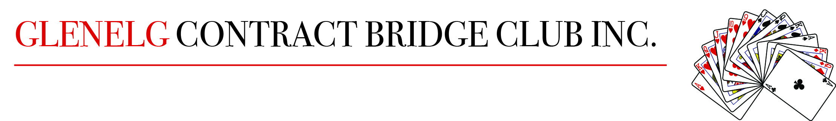
Code of Conduct
Your Club Committee requests that you read the following and abide by the code.
Bridge is a game to be enjoyed, rudeness at the table is forbidden by the Laws of Contract Bridge.
THE DO’s
At the start of each round greet other players and smile.
Volunteer the outline of your bidding system to them and forewarn them of any special calls by your partnership.
Congratulating the good play of your opponents is highly recommended.
Bid and play to time. Claim when you can, stating a line of play.
Accept rulings from the Director cheerfully, without arguing at the table. If you disagree with the Director, you are always entitled to lodge an appeal.
Practise active ethics – when asked for an explanation, give full details of your partnership’s agreement, both explicit and implicit.
THE DON’T’s
Avoid lengthy post-mortems.
Don’t give lessons to your partner or opponents at the table.
Avoid criticisms, even of your partner.
Profanity, badgering, gloating and making insinuations are all unacceptable.
Don’t give your own rulings at the table or if any doubts about results, always call the Director.

Offences of a serious nature will be referred to the committee for action.

