A HISTORY OF THE GLENELG CONTRACT BRIDGE CLUB

COMPILED FROM AVAILABLE MINUTES 1993 - 2017
AND ORAL HISTORIES

by June & Graeme Hammond 2017
updated 2022

History
There is evidence of a bridge club at the Glenelg Town Hall called the Goodwill Bridge Club as early as 1952 (see appendix 1) who used to meet in the Community Room every Wednesday evening. The Goodwill Club was founded in1940 by Mrs R R Boath. They continued to hold their Bridge parties into the 60’s, raising money which was donated to various charities.
The Glenelg Contract Bridge Club Inc. was not founded until Friday, 27th February,1970. (See appendix 2) In the early days, the club met in the Lady Mayoress’ Room, in the Glenelg Town Hall, once a week, on Friday evenings. Keith Berry and Norman Newland were instrumental in founding the club and Gouth McElroy was elected the first President. The two men were very keen to establish clubs in many metropolitan areas throughout Adelaide and Norman Newland went on to establish the Walkerville Bridge Club as well. Helen Luxton, who still plays from time to time at the Glenelg club, was one of the founding members of the club.
She recounts a funny story told to her by Keith Berry, who had an unusual liking for drinking sea water. But he liked it fresh, so he used to take a bucket onto Glenelg Jetty to get his daily drink. One day in 1971, he went onto the jetty and leaned out to hoist up the bucket. As he did so, the instructions for and entries to SA’s first congress at Glenelg which he was organising, fell out of the top pocket of his jacket into the sea below. In a panic, he ran back along the jetty to the beach, stripped to his long johns (it happened to be mid-winter) and in he went to retrieve his paperwork. He was spotted, the police were called and there was some explaining to be done.
When the Glenelg Town Hall was renovated in the 70’s there were several moves: the first was to the Rechabite Hall, Gordon Street, Glenelg in 1976, then to St Mary’s Hall, part of St Mary’s Primary School, High Street, Glenelg for a short time. By the 1977 the Club was in Partridge House, Partridge Street, Glenelg where it stayed for many years. The games were held in several of the rooms and it was felt that it would be better to have everyone together.
In May,1997, the Club moved again, with 2 sessions (Mon & Fri) as well as Pleasant Sundays being played at Holdfast Bay Yacht Club, Barcoo Road, West Beach. In Jan 1998 these 2 sessions were moved to Flambouron Hall, Fulton Street, Glenelg North and continued to be played there for several years. Other sessions were still being played at Partridge House.
Finally, in 1997, the club was playing sessions in the comfortable, bright room of the Sea Rescue Squadron, Barcoo Road, West Beach as fellas a couple of sessions in the Flambouron Hall.
In 2020, the 50th Anniversary of the founding of the Glenelg Bridge Club, the club is still at the Sea Rescue Squadron and thriving with a membership of 176 full members and 56 associate members, which includes social members. There are 4 day sessions, 2 evening sessions, and 2 morning supervised sessions weekly. There are also 4 beginners courses throughout the year. There are 8 qualified directors and 3 accredited teachers a the Club.

Some interesting highlights taken from the Minutes:
1993 approx 350 club members (Appendix 3)
In 1994 Russell Dann designed a double sided pad to be used for silent bidding and they were used at the Glenelg Bridge Club.
1994 was the Club’s 25th year
May 1998, Marie Harnett (McMahon) started bridge lectures and they were generally well accepted and it was decided to advertise in the Messenger to attract new players from outside the club.
1999 Marie Harnett (McMahon) became the first person to have Glenelg Bridge Club as their home club to become a Grand Master.
2003 Kevin Battersby became a Grand Master
2005 Member numbers: 251 financial, of whom 194 were home club members, 6 Life Members
2006 Member numbers: 245 financial, of whom 196 were home club members.
The team of G & J Quinn and J & D White came 2nd in the Regional GNOT finals
2007 The team of J Kleeman, Kevin Battersby (cpt), Obbie Rieziger and Kevin Clapp came 1st in the Regional GNOT finals
2008 In June, former president and long time club member, Kevin Clapp passed away
2009 Kevin Clapp Memorial Trophy, donated by Keith Walshe, was instigated
2011 Audrey Woods, Founder Member passed away 27 Jan
2013 144 members
2017 182 members
2019 216 members
2020 Club’s 50th anniversary, sessions disrupted by COVID shutdowns, new format of Tuesday and Wednesday Supervised sessions, retirement of Peter Williams from Supervised teaching, sessions resumed July 6, club became cashless and eftpos introduced, Glenelg Spring Congress cancelled due to Covid 19
2021 Closed in January due to Covid 19, Barcoo Room painted sessions held upstairs, introduction of Thursday supervised competition. Glenelg Spring Congress cancelled due to Covid 19

Club Presidents:
Gouth McElroy | 1970 - | Tony Souter | 2009
Norm Newland | 1971 | Peter Teubner | 2010-2013
Ricky Parsons | 1972-1976 | Arthur Porter Jnr | 2014 -2018
Alf Gillingham | 1977 - 1978 | Graeme Hammond | 2019 -
Ricky Parsons | 1979 - 1980
Wallie Wood | 1981-1986
Colin Faehse | 1987 - August 1996 (10 years)
Russell Dann | Sept 1996 -1997
Kevin Clapp | 1998 - 2008 (9 years)
Graeme Quinn | Feb - Sept 2008
Alma Gallagher | Sept 2008 - Feb 2009

Life Members
Keith Berry 1972 | Ricky Parsons 1980
Russell Dann 1995 | Arthur Porter 2001
Colin Faehse 1996 | Audrey Porter 2001
Ricky Parsons 1980 | Kevin Clapp 2002
Marie Davies John Huston 1990 | Kevin Battersby 2007
Audrey Wood, Wally Wood 1986 | Obbie Reiziger, Tony Souter, 2011
Alma Gallagher | Patricia Dinan, Marie McMahon 2011
William Lock 2009 | Arthur Porter (Jnr) 2013
Josephine Lock 2009 | Peter Teubner 2015
Kay Weeks 1999 | Peter Williams 2017
Kevin Clapp | Judy Maloney, Helen Wetherell 2019
 | Judy and Graham Quinn 2021

Annual Prizes:
Tuesday Championship
1993 M Stewart & J Riley
1994 J Hood & J Matthews
1995 M Martin & M Harnett
Wednesday Championship
1993 C Faehse & J Huston
1994 K Weeks & M Clapp
1995 M Clapp & K Clapp
Thursday Championship
1993 Audrey & Arthur Porter
1994 D Shilling & J Jackson
1995 J Kleeman & K Battersby

phased out in 1995

Trophy Winners

The trophies that the club presents at the AGM each year for the previous 12 months:

K T Berry Trophy - earned the greatest number of master points in the previous year
1985 M Angel | 2009 Marie Mcmahon
1993 John Huston | 2010 Dulcie Easley
1994 John Huston | 2011 June Kleeman
1995 Michael Clapp | 2012 Marie McMahon
1996 Michael Clapp | 2013 Marie McMahon
1997 Michael Clapp | 2014 Judy Maloney
1998 Kevin Clapp | 2015 Judy Maloney
1999 John Huston | 2016 Judy Maloney
2000 Obbie Reiziger | 2017 Judy Maloney
2001 Obbie Reiziger | 2018 Judy Maloney
2002 Obbie Reiziger | 2019 Judy Maloney
2003 Kevin Battersby | 2020 Judy Maloney
2004 Kevin Battersby | 2021 Judy Maloney
2005 John Huston | 2018 Judy Maloney
2006 Kevin Battersby | 2019 Judy Maloney
2007 Kevin Battersby | 2020 Judy Maloney
2008 Marie McMahon | 2021 Judy Maloney

Wallie Wood Award - earned the greatest number of masterpoints (female)
1994 S Logie | 2007 Iris Hughes
1995 Alessandra Logie | 2008 Iris Hughes
1996 A Schultz | 2009 June Kleeman
1997 Helen Luxton | 2010 Marie McMahon
1998 Kathleen Job | 2011 Judy Maloney
1999 June Kleeman | 2012 Iris Hughes
2000 June Kleeman | 2013 Iris Hughes (deceased)
2001 June Kleeman | 2014 June Kleeman
2002 Doreen Tomlin | 2015 June Kleeman
2003 Doreen Tomlin | discontinued in favour of encouragement award
2004 Doreen Tomlin
2005 Doreen Tomlin
2006 Doreen Tomlin

Wallie Wood Award - beginners’ encouragement award (less than 5 mpts at beginning of year)
2016 John Abbey ( inaugural winner)
2017 Jeff Searle
2018 Helen Fehlberg
2019 Jack Chyer
2020 Michelle O’Regan
2021 Yvonne Armstrong

Kevin Clapp Memorial Trophy - outstanding service to the club
2009 Kay Weeks (inaugural winner)
2010 Tony Souter
2011 Helen Mander
2012 Arthur Porter Jnr
2013 Bill Jensen
2014 Kay Crossan
2015 Jenny Artis
2016 Bill Jensen
2017 Judith Blackstone
2018 Judith Blackstone
2019 Julie Clark
2020 Bill Jensen
2021 Joy Giles

Patron’s Trophy - ranking of regional * or less, most improved

2008 Judy Maloney (presented by Duncan McFetridge)
2009 Keith Walshe (presented by Duncan McFetridge)
2010 Eddie Skala (presented by Ms Kate Cunningham on behalf of
Duncan McFetridge)
2011 Ramon Walton (presented by Peter Teubner, President)
2012 Trevor Oliver
2013 George Lupul
2014 Peter Hayles (presented by Duncan McFetridge
2015 Claire De Lambert (presented by Duncan McFetridge)
2016 Julie Clarke (presented by Duncan McFetridge)
2017 Josie Cock (presented by Duncan McFetridge)
2018 Josie Cock (presented by Stephen Patterson)
2019 John Abbey (presented by Stephen Patterson)
2020 Julie Roberts (presented by Stephen Patterson)
2021 Julie Roberts (presented by Stephen Patterson)

Student of the Year Award
2016 Ross Grantham (inaugural winner)
2017 Ruth Summers
2018 Jon Parrington
2019 Richard Trigg
2020 Discontinued

Spring Congresses at Glenelg
Location | Director | best ranked home members
1998 Flambouron Hall | David Anderson. | M & K Clapp
1999 Flambouron Hall | David Anderson | M & K Clapp
2000 Flambouron Hall | David Anderson | M Harnett & M Clapp
2001 Flambouron Hall | Michael Clapp | Sue Phillips & Obbie Reiziger
2002 Flambouron Hall | Michael Clapp | Sue Phillips & Obbie Reiziger
2003 Flambouron Hall | David Lusk
2004 Flambouron Hall | David Lusk
2005 Sea Rescue Squadron | Phil Gue | Geraldine Eitzen & Kevin Clapp
2006 Sea Rescue Squadron | Phil Gue
2008- 2019 Sea Rescue Squadron | David Anderson
2020 - 2021 | cancelled due to COVID 19
2022 | David Anderson | Christian Mehuys & Keith Walsh

GLENELG CONTRACT BRIDGE CLUB INC – HISTORICAL DATA

The foundation meeting for formation of the club was organised by Keith T Berry on Friday, 27th February 1970 at the Glenelg Town Hall.

FOUNDATION Keith T Berry Audrey M Wood
MEMBERS: Norman D Newland Wally G Wood
William J Maither Ron L Coulls
Mrs K Miers Mrs Win Foster
Lal McElroy Elma Bowden
Gouth McElroy Mr & Mrs S J Miller
Eric A Hayward Bruce Beig
Mr & Mrs Alec Gregory June Beig
Mrs Salas Helen Luxton
Mrs R J Cummins John Luxton
Mrs L Saies Alice Kastbeerg
June Martin

LIFE
MEMBERS: Keith Berry Ricky Parsons
Audrey Wood Wally Wood
Marie Davies John Huston
Colin Faehse Russell Dann
Audrey Porter Arthur Porter
Kevin Clapp Kay Weeks
Alma Gallagher Kevin Battersby
Josephine Lock William Lock
Obbie Reiziger Pat Dinan
Tony Souter Marie McMahon
Iris Hughes Arthur porter Jnr
Peter Teubner Peter Williams
Judy Maloney Helen Wetherell
Judy Quinn Graham Quinn

PRESIDENTS: Gouth McElroy 1970
Norm Newland 1971
Ricky Parsons 1972 – 1976
Alf Gillingham 1977 – 1978
Ricky Parsons 1979 – 1980
Wally Wood 1981 – 1986
Colin Faehse 1987 – August 1996
Russell Dann Sept 1996 – 1997
Kevin Clapp 1998 – 2008
Graham Quinn Feb 2008 – Sept 2008
Alma Gallagher (Vice Pres) Sept 2008 – Feb 2009
Tony Souter 2009
Peter Teubner 2010 – 2013
Arthur Porter Jnr 2014 - 2018
Graeme Hammond 2019 -

SECRETARIES: Keith Berry 1970 – 1972
Wally Wood 1973 – 1980
John Juston 1981 – 1983
John Matthews 1984 – 1985
Peggy Barrett 1986 – 1989
John Huston 1990 – 1991
Josephine Horton 1992 – 1993
John Huston 1994 – 1995
Stephanie Dalle Nogare 1996
Kay Weeks 1997 – 2009
Dulcie Easley 2010 - 2011
Helen Wetherell 2012 -

TREASURERS: Keith Berry 1970 – 1972
Audrey Wood 1973 – 1975
Mary Guillingham 1976 – 1977
Win Alban 1978
Robert Henshaw 1979 – 1984
Marie Davies 1985 – 1997
Audrey Porter 1998 – 2008
Marie Davies 2009 - 2011
Antonina Hayles 2012 – 2014
Gillian Gordon 2015 -

Appendix 1: Members’ List 1993

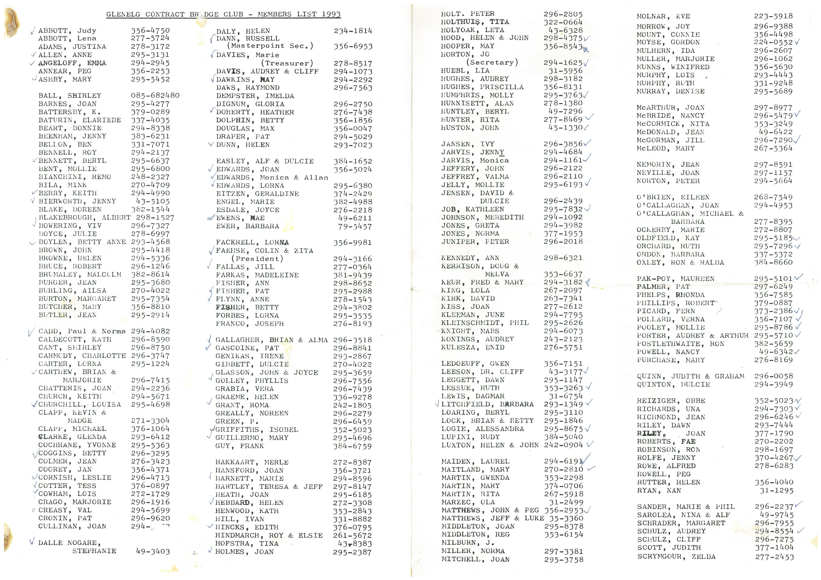
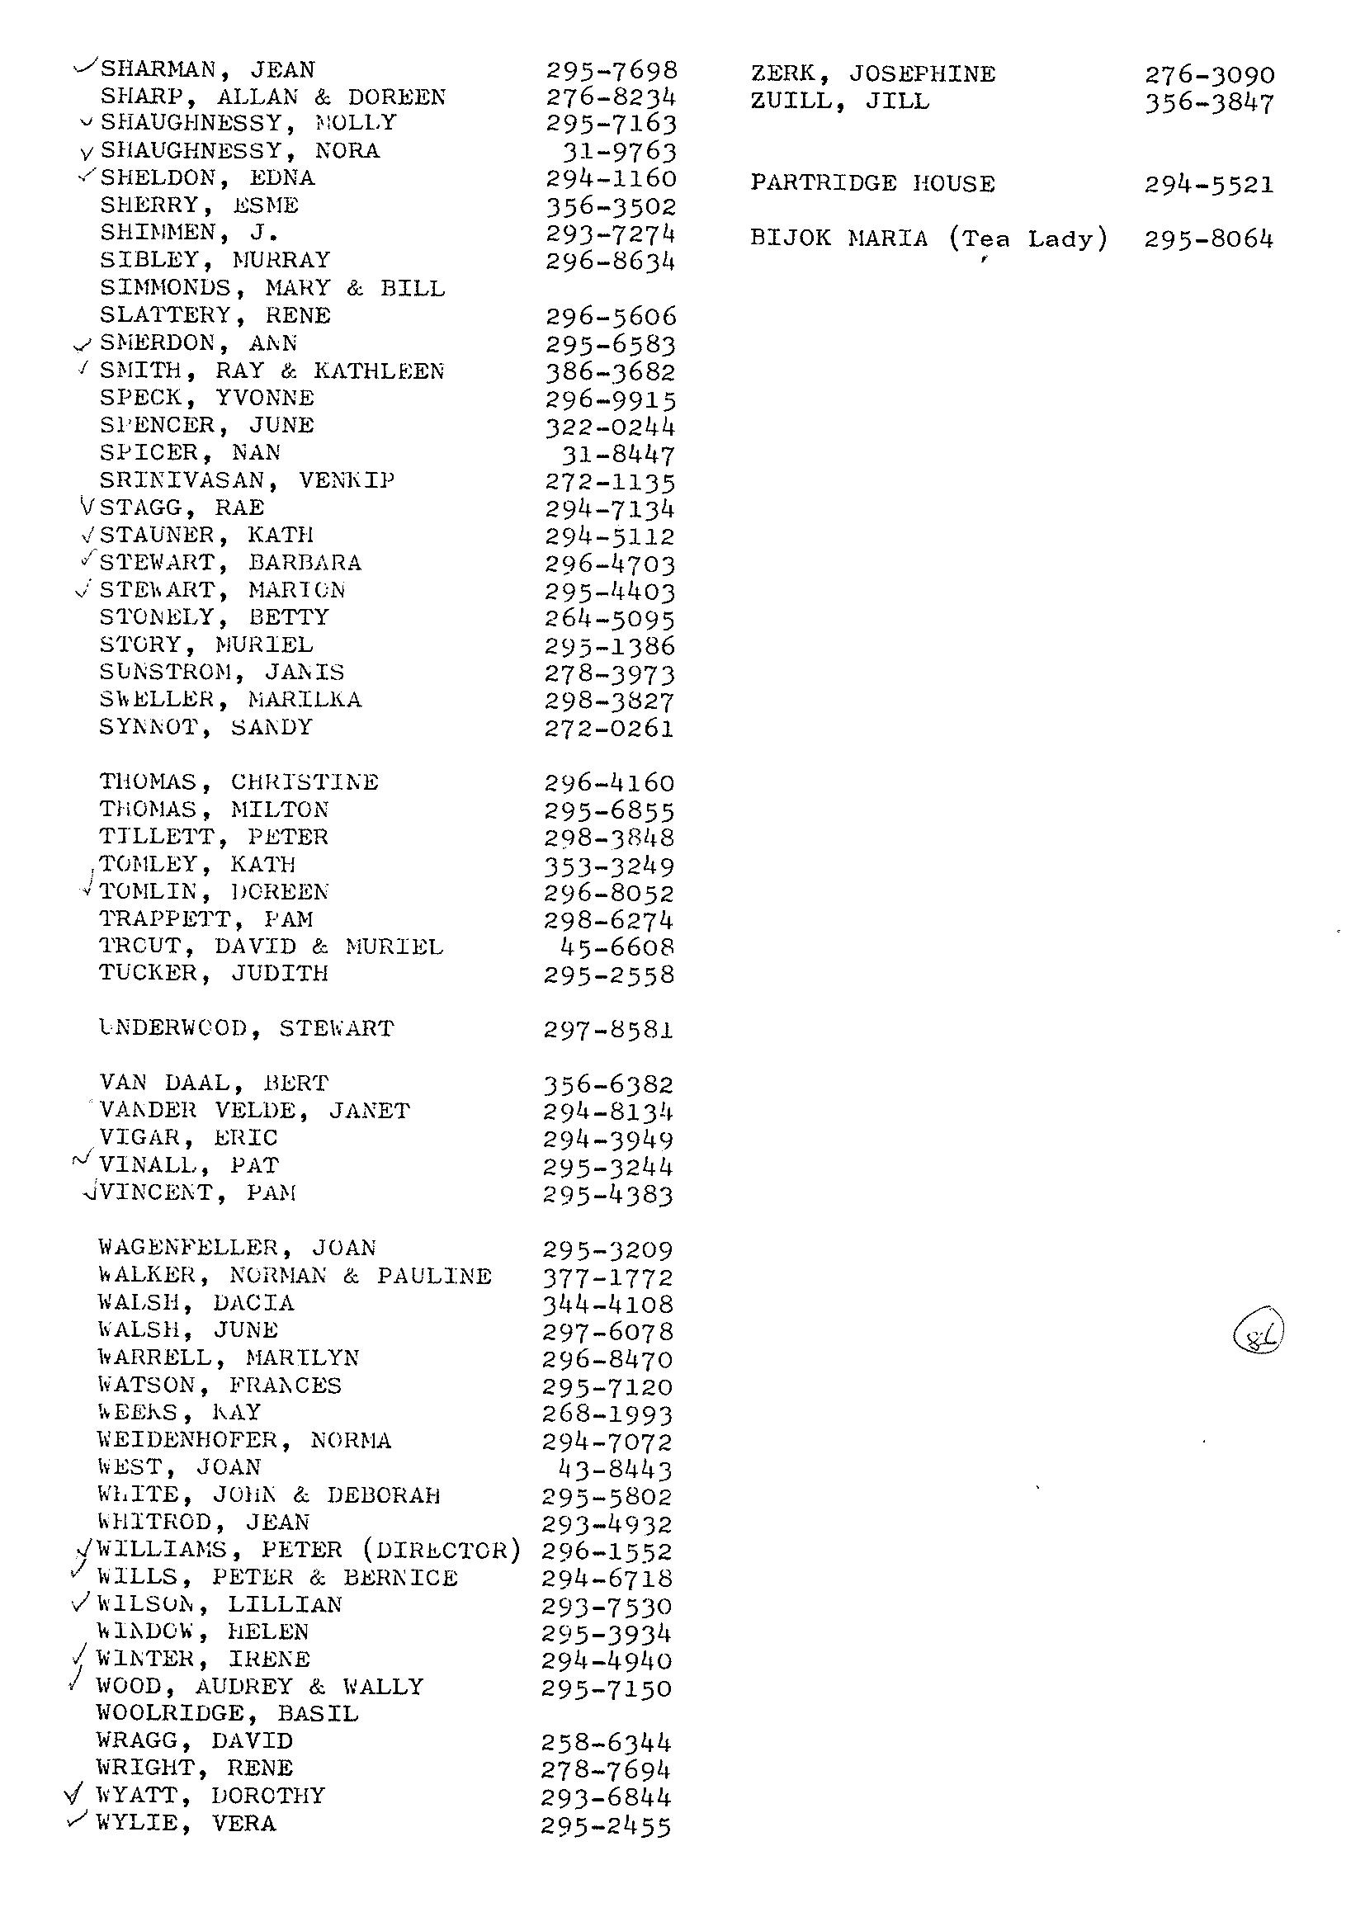
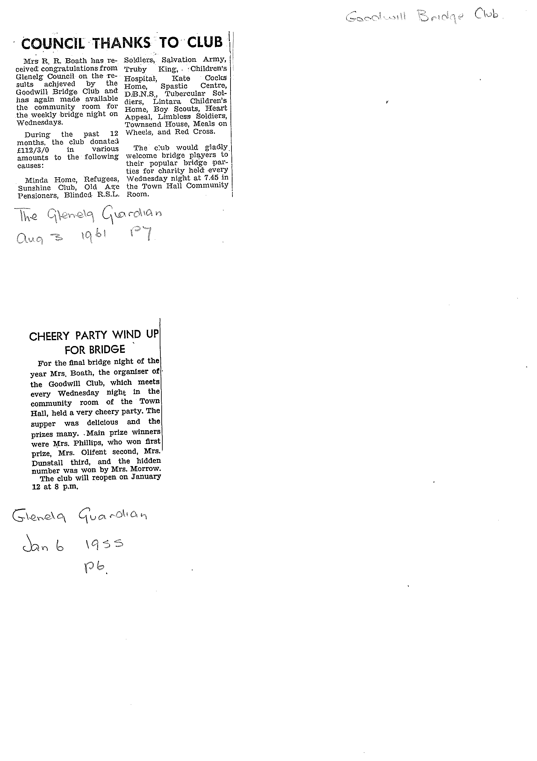

Appendix 2a

This information was found in the Minutes Book, 7/7/1993 - 8/12/1998 and is faithfully reproduced below:

Club Formation

GLENELG CONTRACT BRIDGE CLUB, INCORPORATED.
HISTORICAL NOTE

A meeting was arranged for Friday, 27 February 1970, at the Glenelg Town Hall, resulting in the club being formed. It commenced operation on the following Friday in the Community Rooms at the Town Hall.
The club continued to use the Community Rooms until 1976, when the accommodation became insufficient for the number of members. They then hired rooms at the Rechabite Hall in Gordon Street, for one night each week.
At this time the Town Hall was undergoing reconstruction, and the Glenelg Council had bought Partridge House, at 38 Partridge Street. The Town Clerk of the time, Mr R. G. Lewis, asked me (Keith Berry) for an opinion of what the club would have to say if accommodation were to be made available at Partridge House. My answer was “I think they would be most appreciative.” He then said to me, “All right, leave it to me.”
On 5 February, 1977 Wally Wood and Rick Parsons looked at Partridge House. On 11 February, 1977, the club held its Annual General Meeting and Alf Gillingham was elected President.
On Friday, 1 June 1977 the Club held its firs night’s bridge at Partridge House.

Keith Berry

These notes were compiled from personal recollections and reminders from Audrey (Mrs Wally) Wood

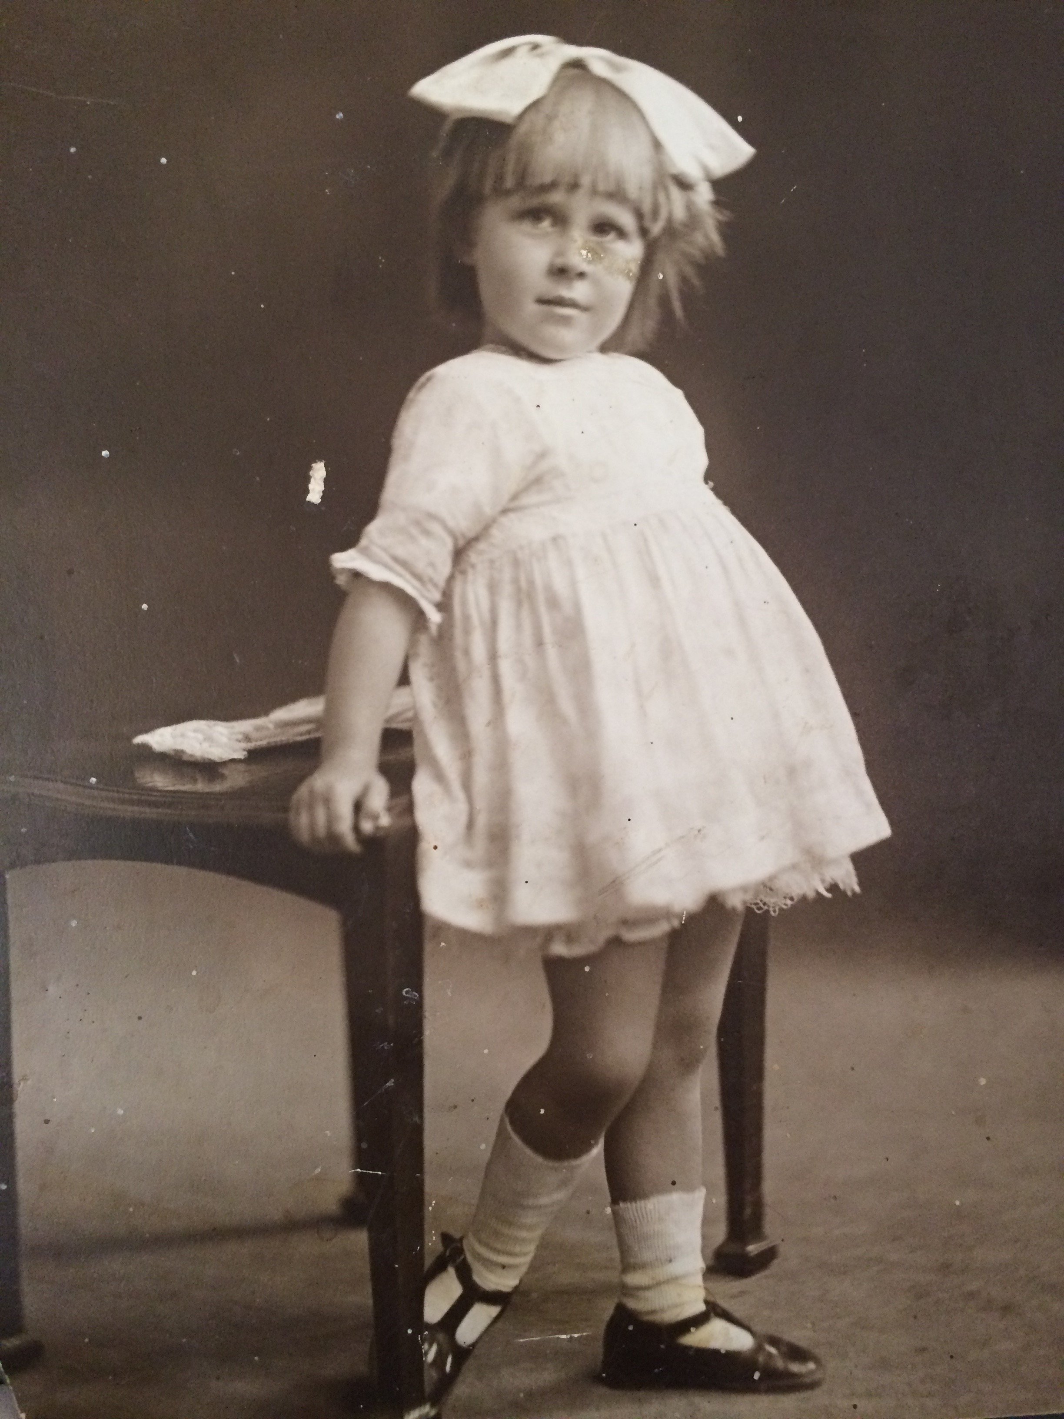
Member Profile - Shirley Clissold

Recently I had the pleasure of interviewing the oldest member of Glenelg Contact Bridge Club, Shirley Clissold. Shirley was born in Broken Hill on June 26th, 1918.
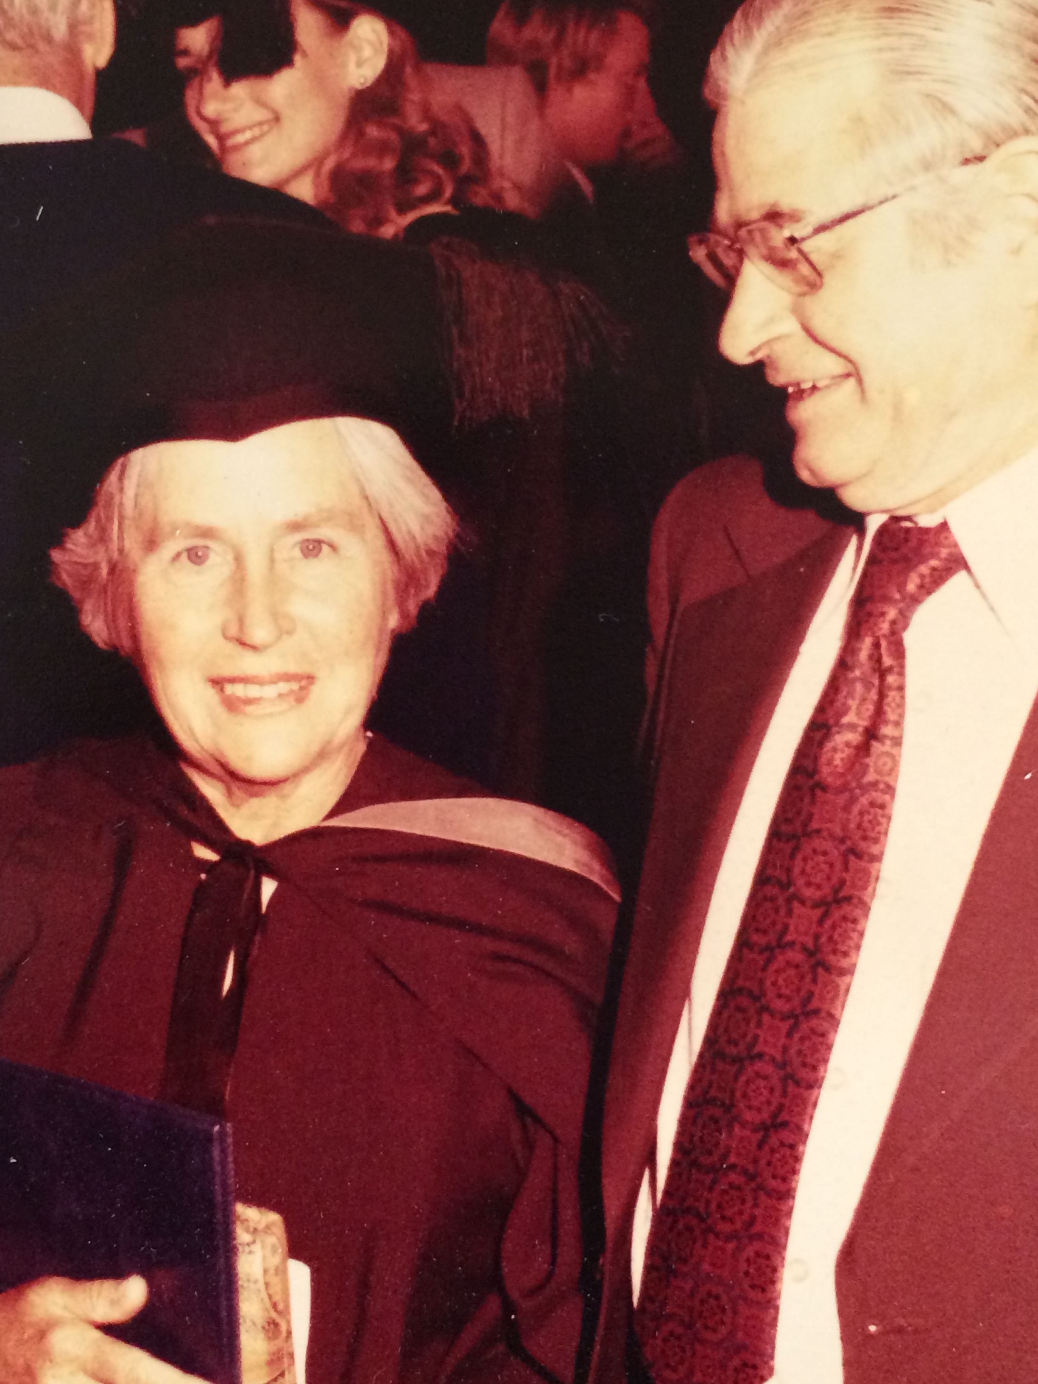
Her early life was spent in Broken Hill. As a young woman she married and was busy with 3 children, John, William and Margaret. Later, when they were living in Quorn in 1958, she was approached to take on a teaching position at the local school as there was a severe shortage of teachers. Shirley wasn’t qualified at the time but she started doing her Bachelor of Arts degree by correspondence and finally qualified in Bathurst with her Diploma of Education in 1978 at the age of 56. Many students in many schools have been influenced by her love of learning in the fields of English, Asian History and History.
Shirley first started playing bridge in 1981 under the tutelage of Cath George at SABA Unley and went on to join Glenelg Contract Bridge Club when it was based at Partridge house, Glenelg South.
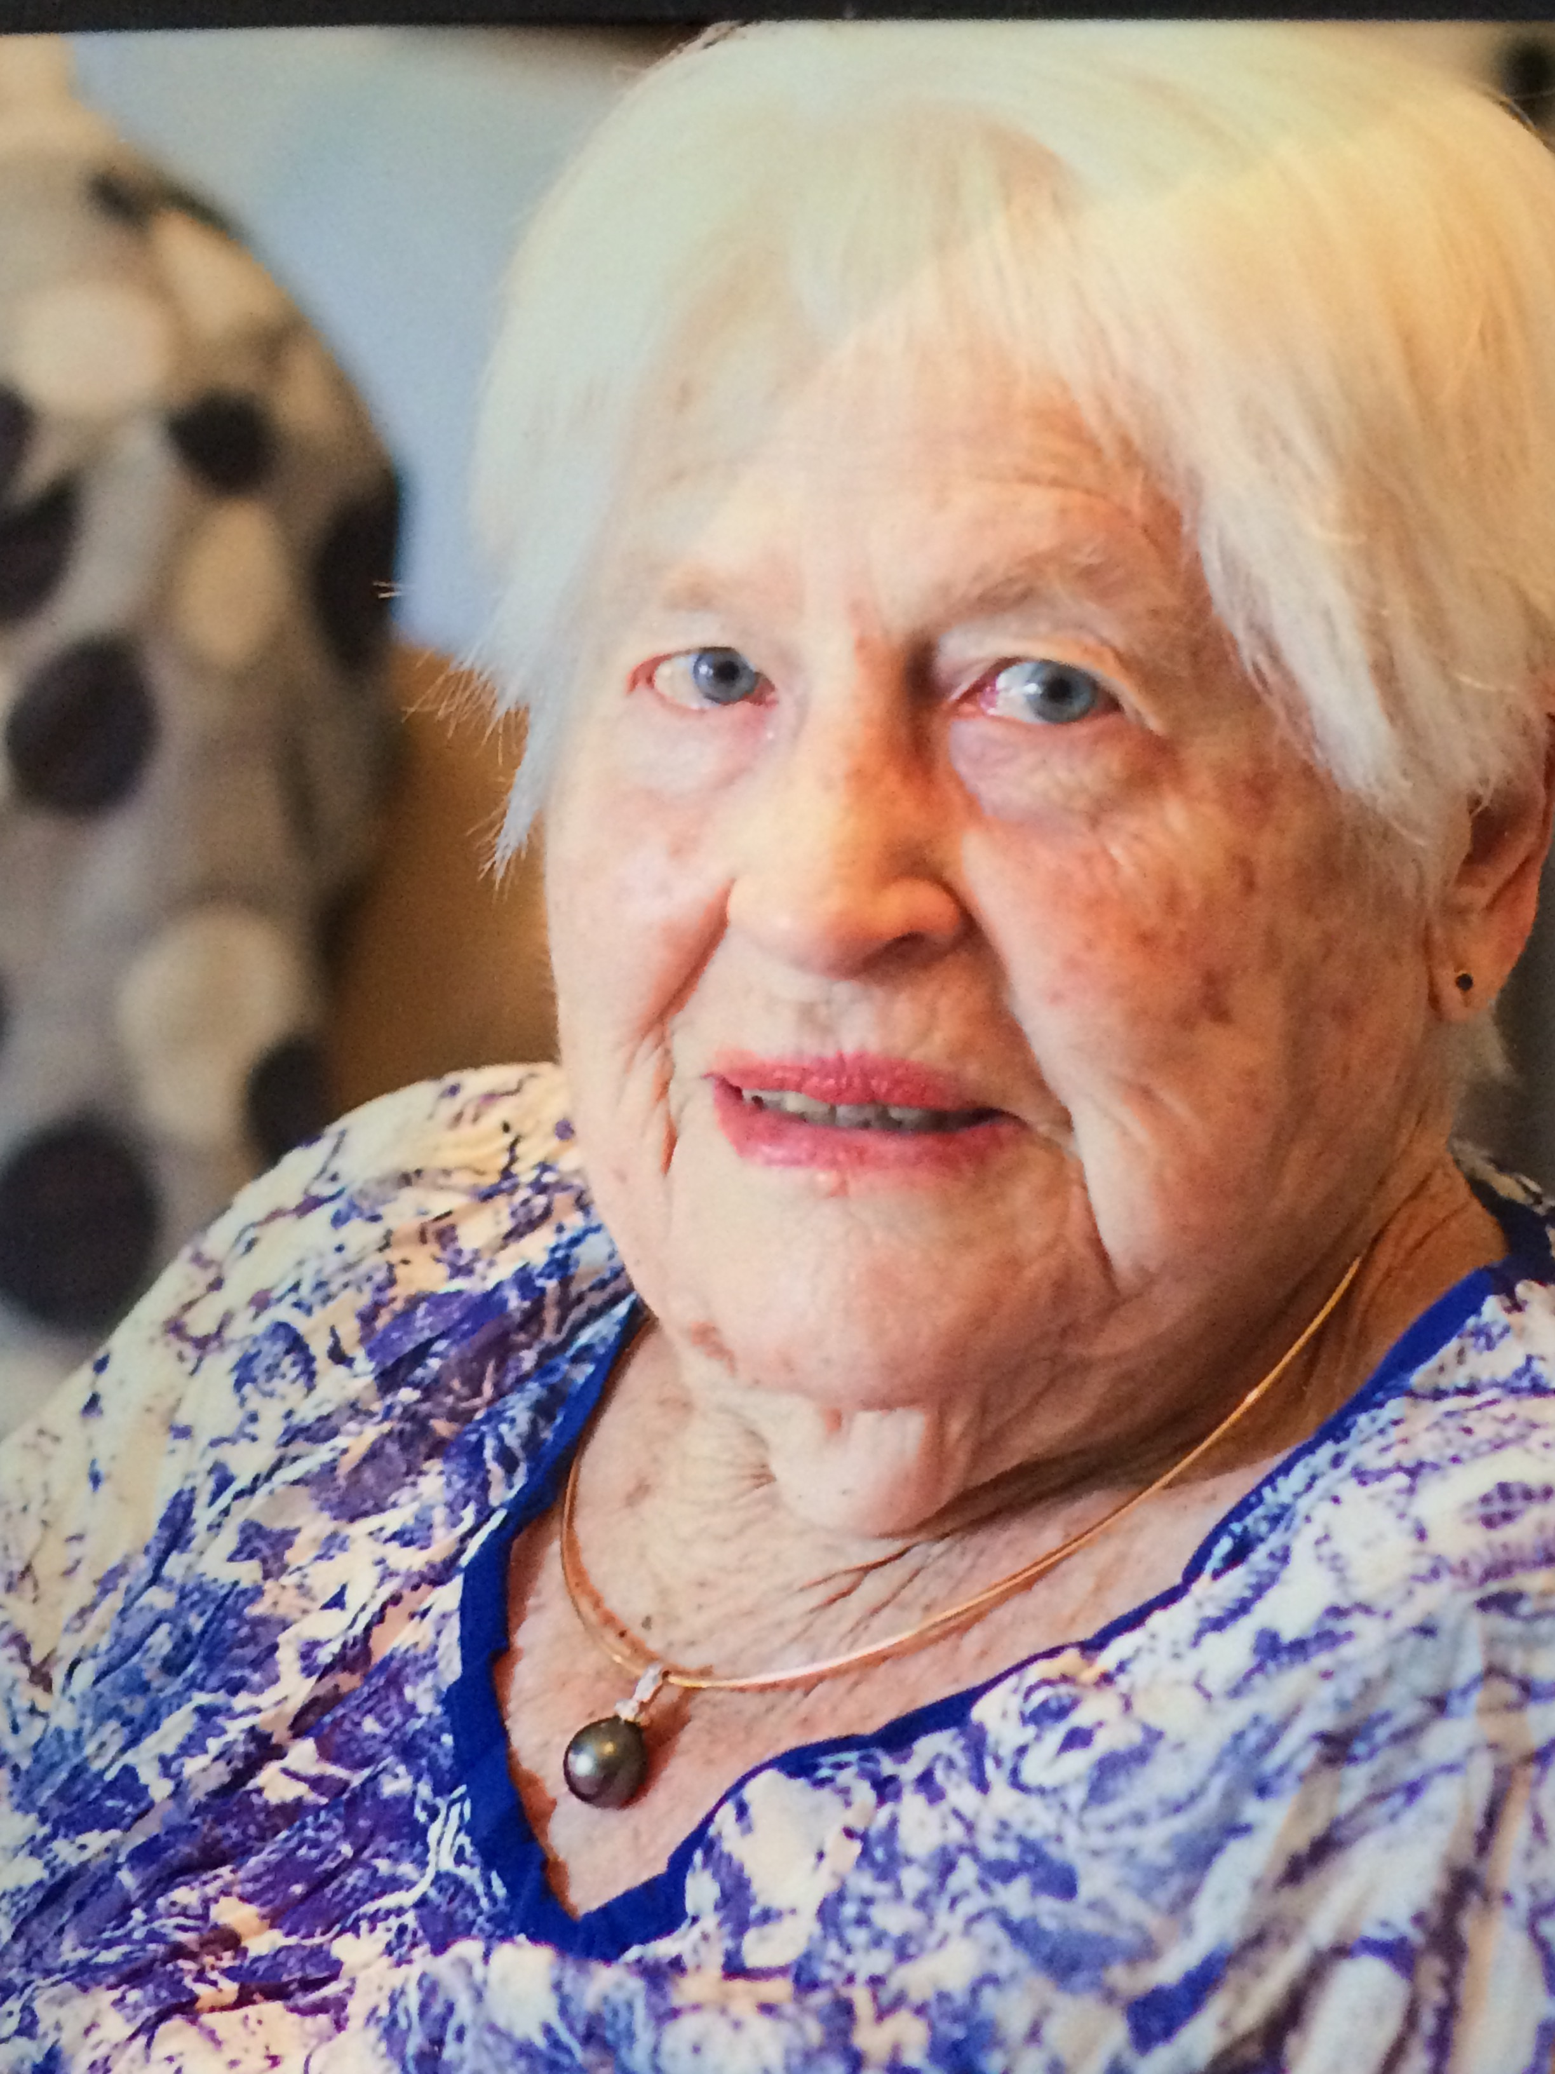
These days her time is taken up with her love of painting portraits and landscapes. She plays competitive bridge once a week on Friday afternoons as well as socially with friends. She loves spending time with her children and 5 grand-children who all live in Adelaide.
Shirley has a wicked sense of humour and when asked the secret to long life she quipped “Plenty of whiskey and loose living!” I like her style.
Thank you Shirley
June Hammond

Member Profile -Bill Blunden
Recently I had the pleasure of spending some time with Bill and getting to know him. Bill was born in London on Valentine’s Day, 1932. As a 7 year old he was evacuated from London to Norfolk for 3 months but when he returned to London for Christmas that year his family decided that they would stay together for the duration of the war years.
His memories of that time include an overwhelming impression of great noise. They lived in Edmonton, North London, close to the Royal Small Arms Factory at Enfield which was often targetted. Their house was within walking distance of White Hart Lane, home of Tottenham Hotspur Football Club, but Bill was and is an Arsenal fan, much to the chagrin of his father. They often used to sleep under the stairs at night and he recalled a particularly frightening event. One Sunday as the family was having lunch they heard the terrifying noise of a Buzz Bomb overhead. These weapons were recognisable by the sputtering noise they made. It was when the noise stopped that the bomb could drop out of the sky. The Blunden family heard the noise stop and they all jumped under the dining room table. They were fortunate as the bomb floated further on and came to ground nearby.
After Bill graduated from school he worked in the Civil Service as a clerical officer, then went on to do 2 years National Service in Germany and 3 years in the Territorial Armies, similar to Australia’s Army Reserves.
Bill married and had 2 children, and immigrated to Australia in 1972. He has 5 grand children and 6 great grand children with another expected very soon.
His love of bridge began in 1970 when a group of work mates from Hawker Sidley Dynamics started playing bridge and soon became good enough to enter the competitive county leagues.When he arrived in Noarlunga from London, Bill wanted to continue his bridge playing and became a founding member of St Vincent Bridge Club. He was on the inaugural committee and went on to be President of the Club twice. He is a life member of that club and was recently given a volunteer’s award for service to the club. In fact, Bill is very pleased that they now have a trophy named after him.
Since moving to his new address, he continues to play bridge four times a week. Bill is a very dedicated bridge player and when asked for a tip for beginners, he advised “Choose a system which is 90% natural”
His other interests include music, especially opera and reading biographies and historical literature.
Thank you to Bill and Topper, his beautiful cat.
June Hammond

Member Profile - Jean Colmer
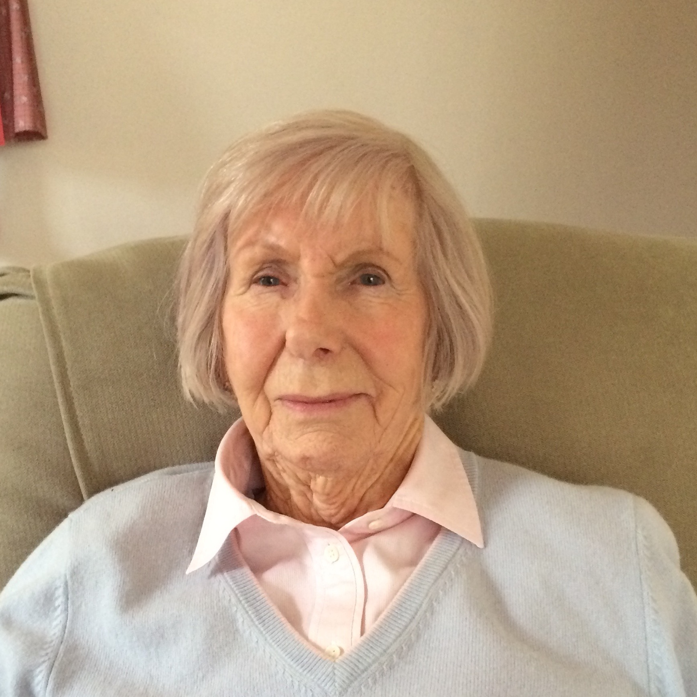
For those of you who don’t know who Jean Colmer is, she’s the lady with the mischievous twinkle in her eye and the wry quip to greet you at the bridge table.

This born and bred Adelaide girl was the 6th of 7 children. She was born in a difficult time,1931, during the Depression years and just before WW2.
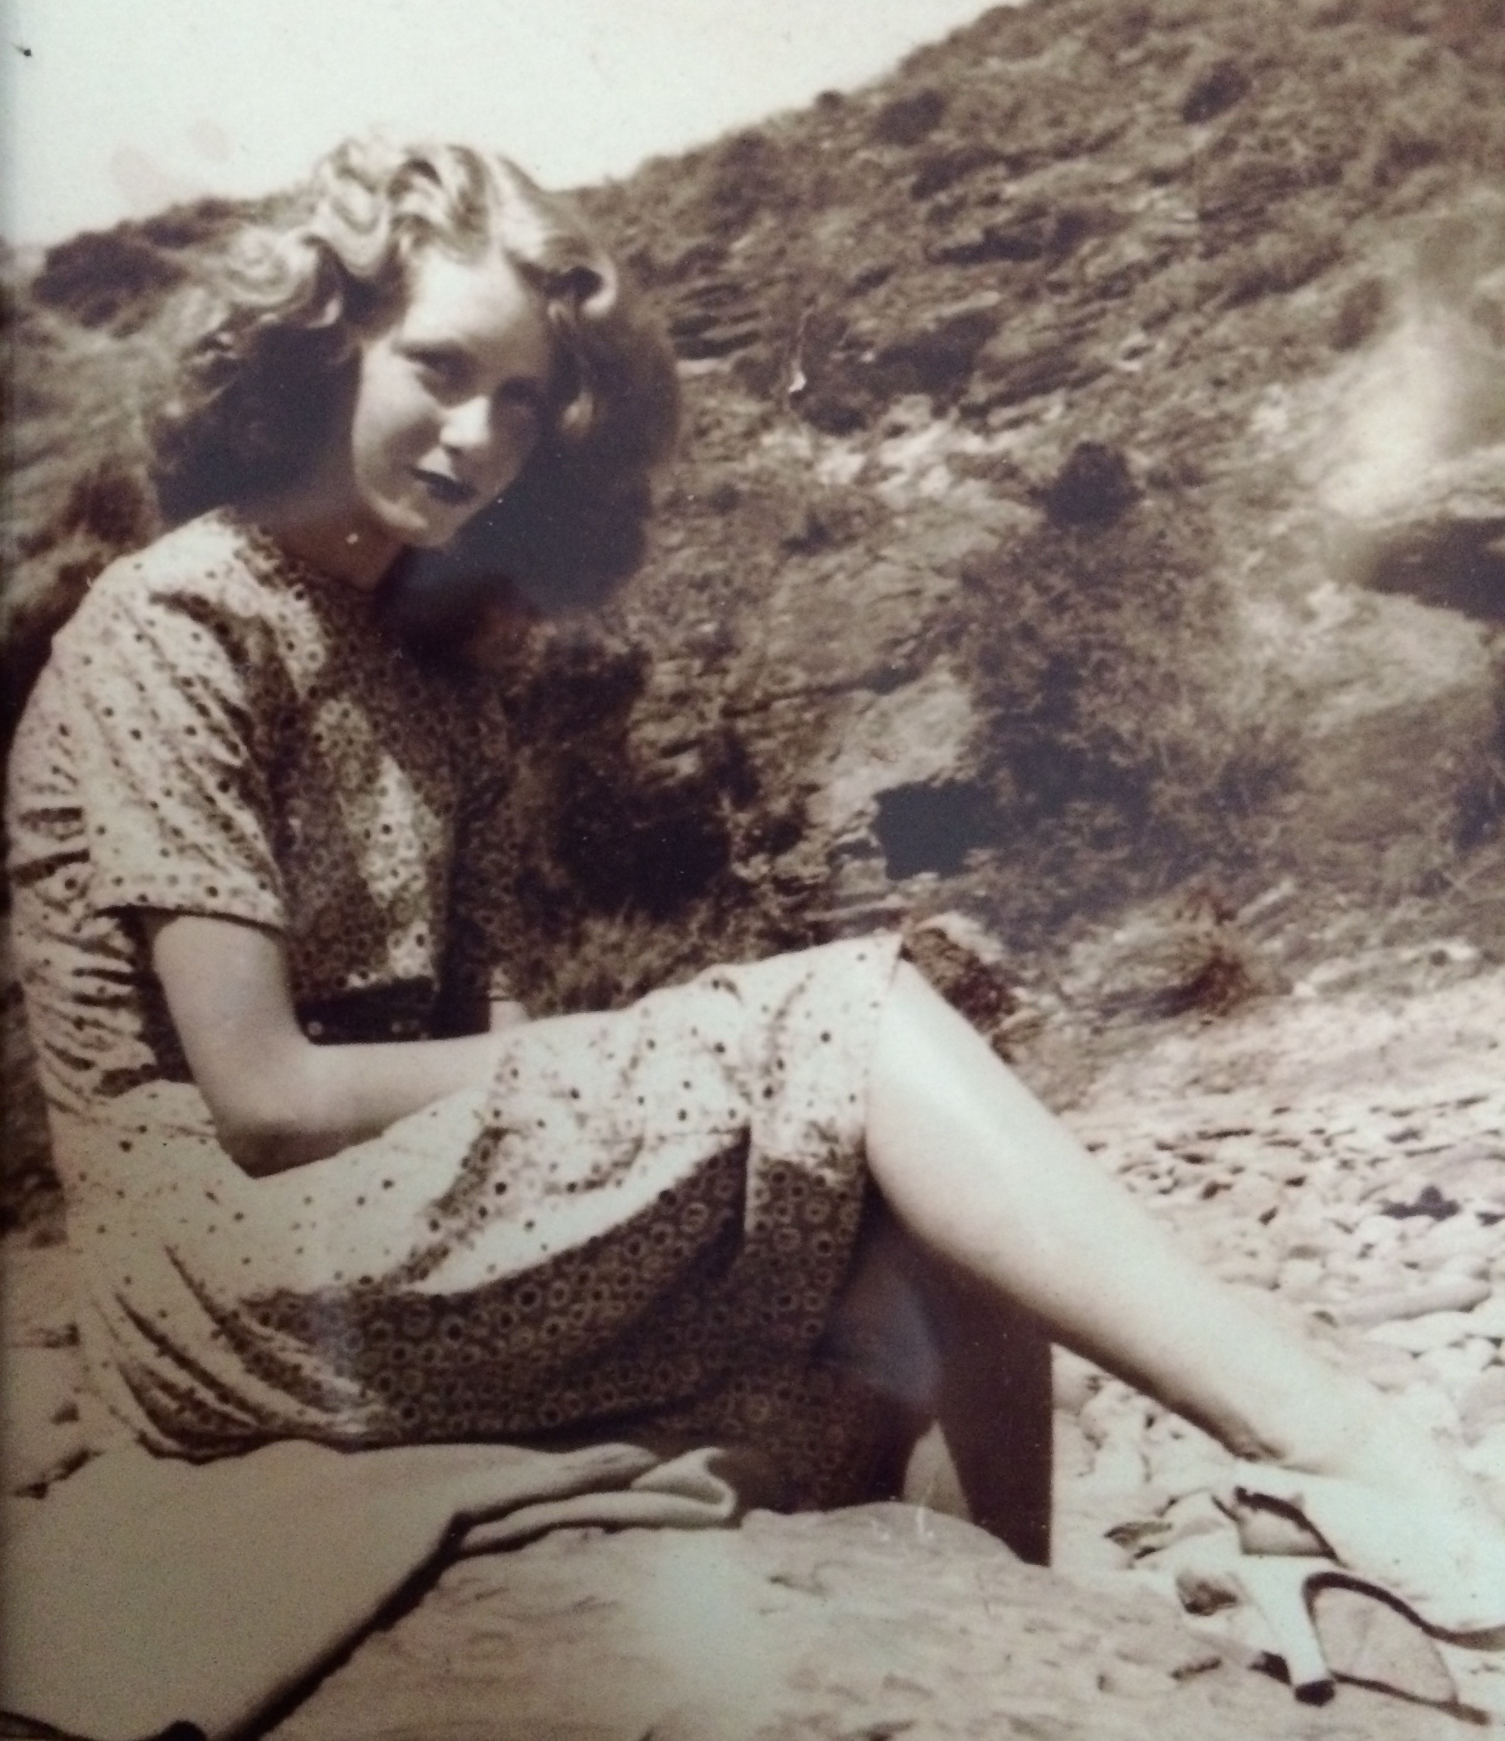
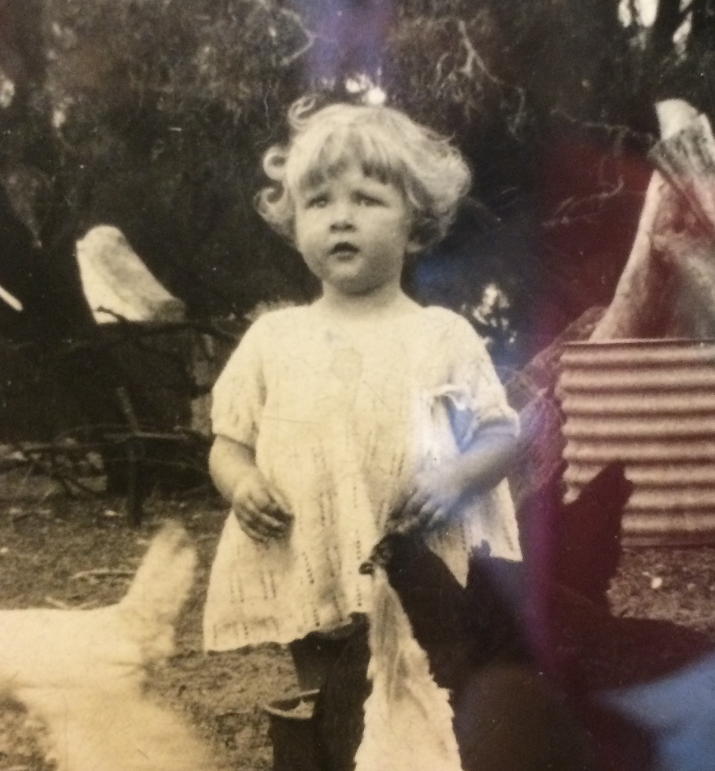
She had to leave school early to find work to help support her large family. She was very attractive and was married at a young age.She had 3 children, the oldest of whom, Jenny Artis, also plays bridge at the Glenelg Bridge Club. Member Profile: Marie McMahon
She raised the 3 children on her own and as a single mum from the age of 25, bought and sold several homes and owned and ran a mixed business for 5 years. During this time, she also became a qualified dressmaker. She went on to work as a dressmaker and still makes all her own clothes.

Jean started playing Association Croquet in 1984 and the game became her passion. Her highest achievement was winning the South Australian Doubles Championship. She still plays 3 times a week at the Brighton Croquet Club.
In 1986-87 she became very ill and found herself wheelchair bound. She attributes her rehabilitation to continuing to play croquet, making herself stand to take her shot and then to sit herself down again. It was during this time, at the urging of a friend, that she took up Bridge at Partridge House.

Jean also did very well at Competition Bridge and represented South Australia with her long-time friend and partner, Iris, in Canberra. She reports that they didn’t do all that well but that they kicked up their heels and had a great time together.

Her spare time is taken up with gardening and sewing, and in 2014, she went with Jenny on a magnificent trip to Europe, visiting Russia and many wonderful places along the way on their Riverboat cruise.

Jean is a strong, determined and resilient woman whose life has been anything but boring. She often says at the end of a bridge day that she is off home to have her “medicine”, so Jean, I’ll drink to that and toast to you.

Thank you for a lovely afternoon, Jean.
June Hammond

Born in Adelaide in 1934, as the only child of 2 bridge players, Marie McMahon was destined to be a Bridge Grand Master. Marie grew up in Adelaide during the war and the aftermath of the Great Depression and attended the first Montessori kindergarten in Australia at St Aloysius College in 1940.
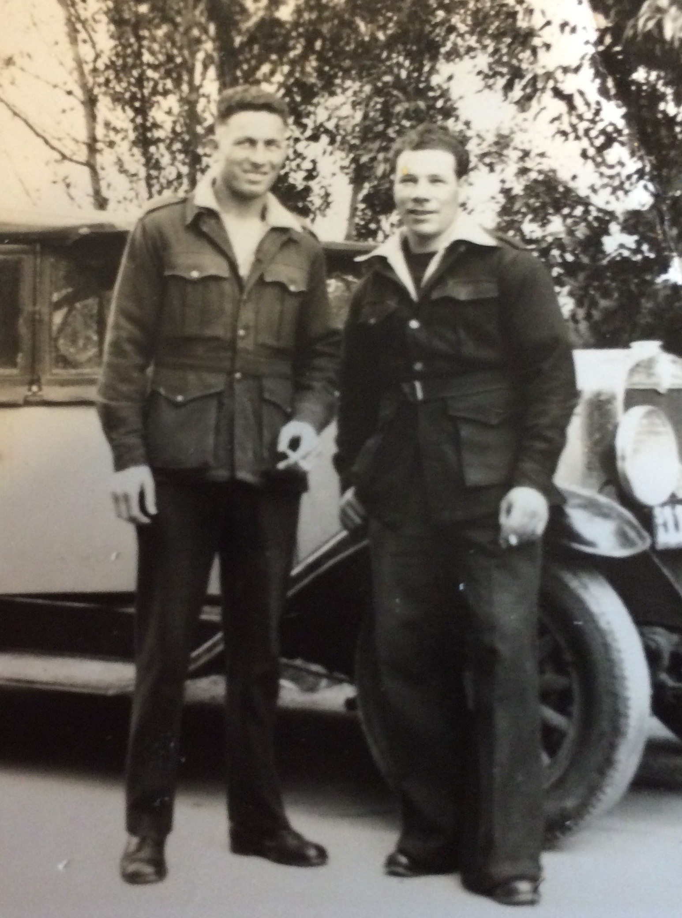
While her father was away during the war years, Marie and her mother spent time at the family farm in Milang. Her strongest memory of the time was of 2 Italian POW’s who were captured in North Africa and were sent to her Aunty’s farm to help out while the men were away. One of them, Martino, saved Marie’s and her 2 cousin’s lives by putting himself in front of a charging bull. He had a crushed chest and was still in the Royal Adelaide Hospital when Marie’s grateful father came home from the war.
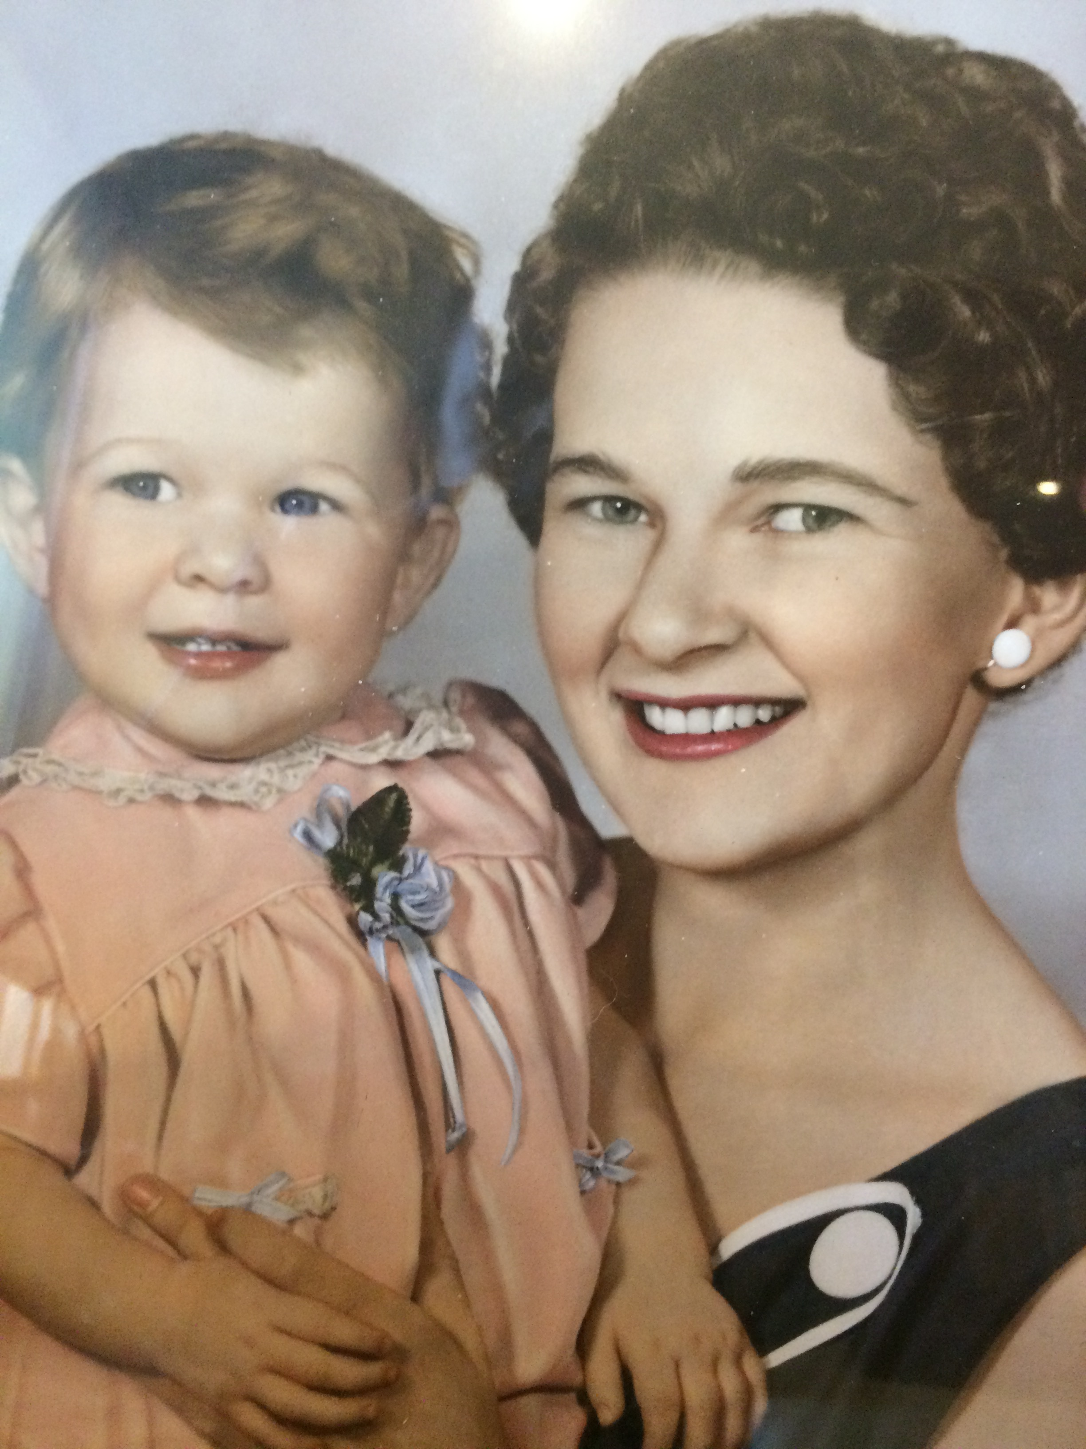
Although Marie wished to continue to pursue her love of singing at the Conservatorium that wasn’t to be and she left school and started work at the Taxation Department. Of course, when she married Frank in 1955 in St Patrick’s Church in Grote Street, she had to resign from her government job, as was the lot of women in those days. She and Frank went on to have 3 children, Claire, Ruth and Craig, who were somewhat separated in ages with 13 years between the first and last.
She enjoyed golf and tennis, as well as singing Gilbert and Sullivan operettas, which were a particular favourite of her father’s.
From the time she was a toddler she was surrounded by people playing bridge as her mother ran bridge evenings at home and eventually started a bridge club at the Richmond Catholic school Hall.
This tradition of starting bridge clubs continued with one of Marie’s proudest achievements, and one which gave her a lot of fun. This was her part in setting up the Robe Bridge Club. More than twenty years ago Marie was working near Robe and was dying for a game of bridge. A friend gave her the phone number for the bridge club but it turned out to be a bridge afternoon in a private home. Once the group realised that Marie taught bridge they encouraged her to give some lessons at Robe during the winter. Never the shrinking violet, Marie took on the challenge and soon found herself on the bus to Robe with 8 of her bridge books under her arm. When she arrived the girls advised her that they had booked out the pub with 38 eager students. The weekly bus trips continued, the club became a fixture and soon a congress was organised. The club is going strong and the congress became an annual event.
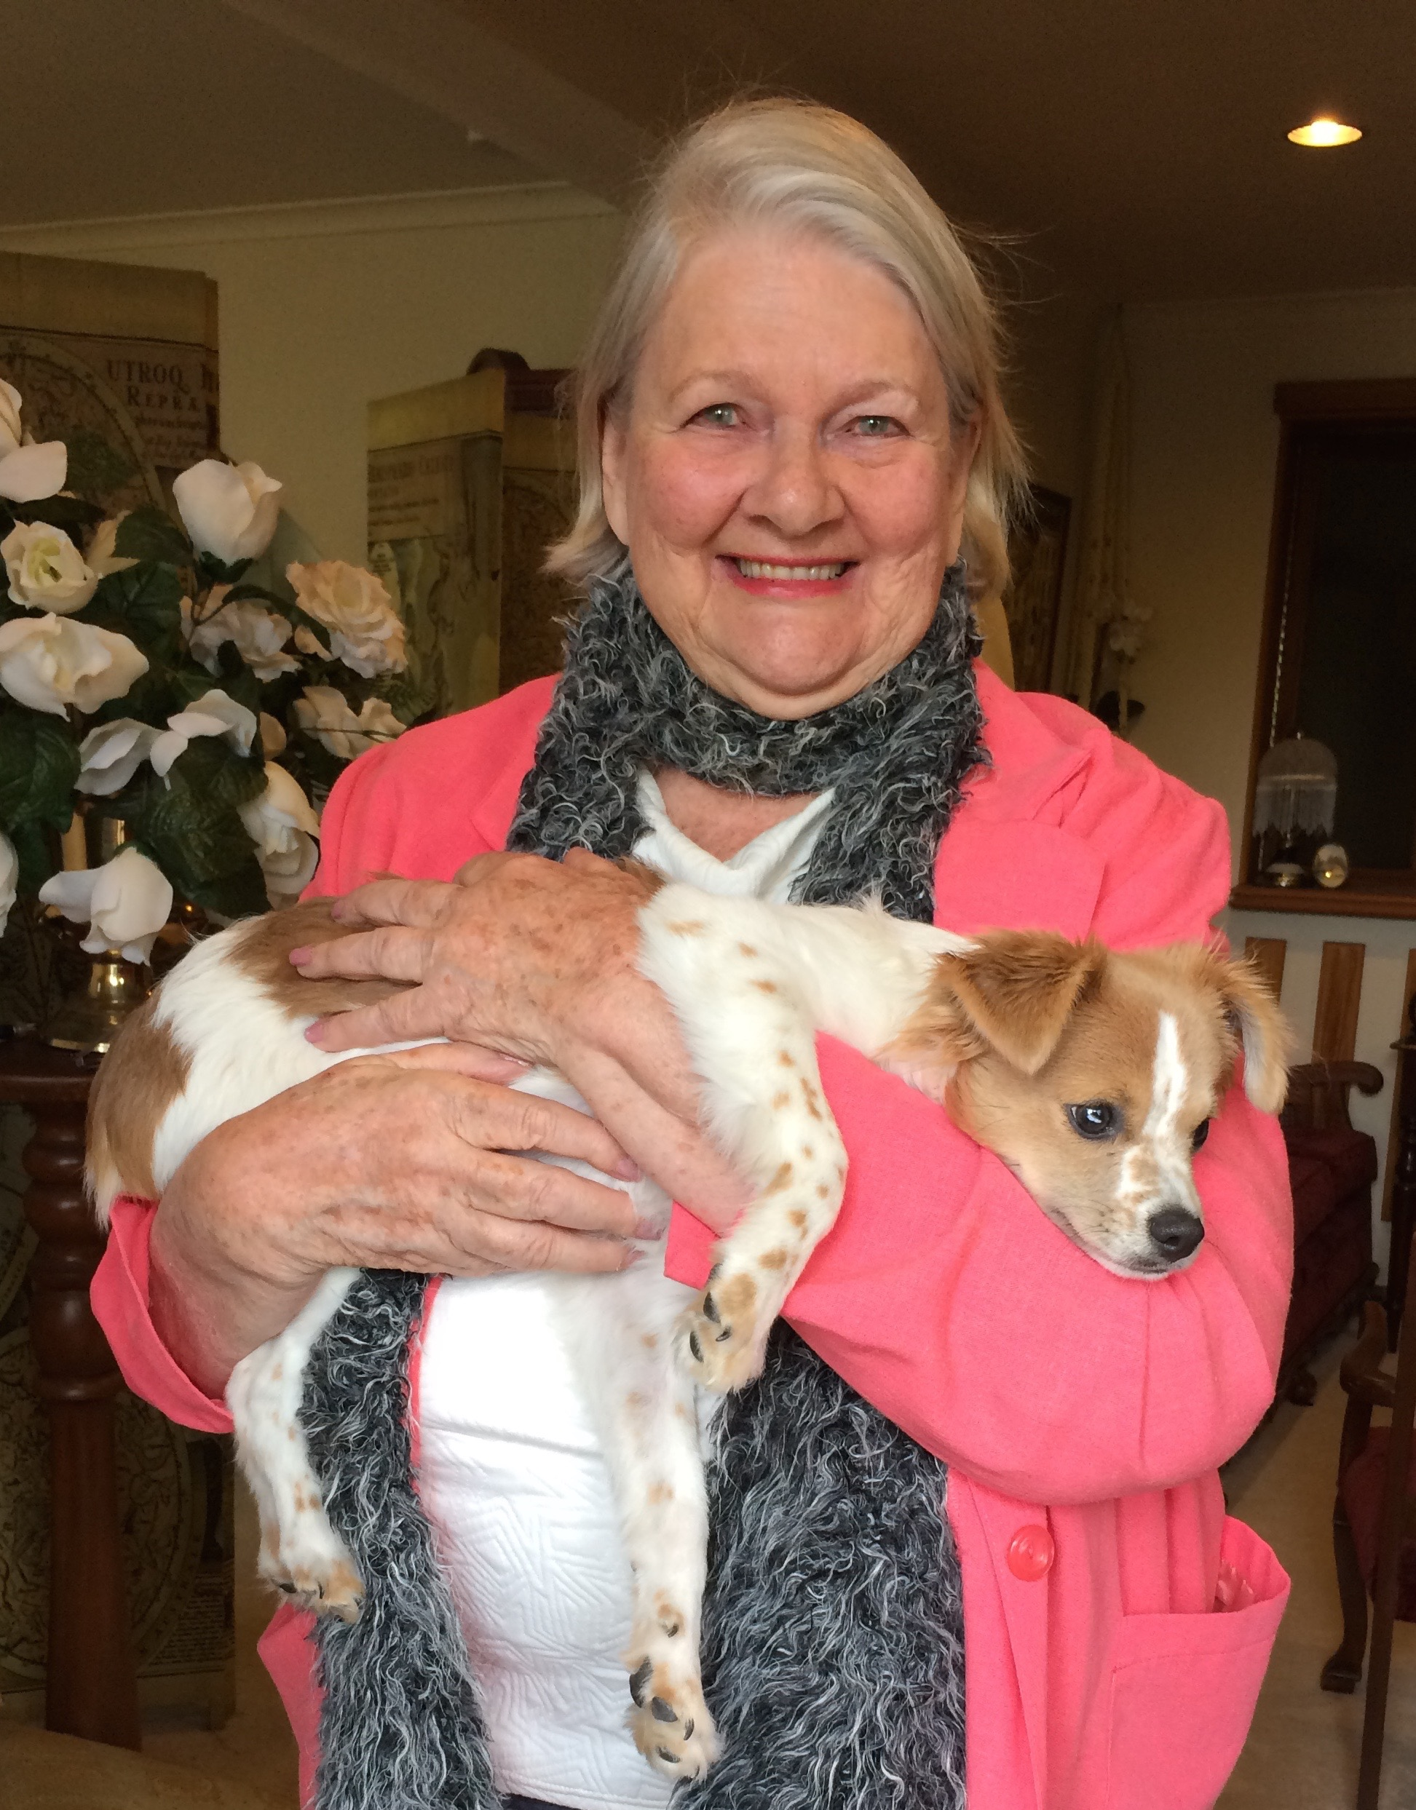
Marie also organised and ran 3 bridge cruises on the River Murray, staying on the Proud Mary over a long weekend. The cruises started in the early 70’s and the final one was in 2006.
Amongst her many achievements in bridge, Marie was the first member of the Glenelg Club to become a Grand Master, she was a member of the South Australian Women’s Team, and she won a gold medal in the swiss pair, the only pair from Australia who got into the finals, in the Trans-Tasman Masters Games in 2004.
Marie’s infectious enthusiasm for the game was experienced every Wednesday morning at the Glenelg club and, on behalf of all of her many past students, I wish to thank her for her love of and dedication to this wonderful game.

June Hammond

Arthur Porter
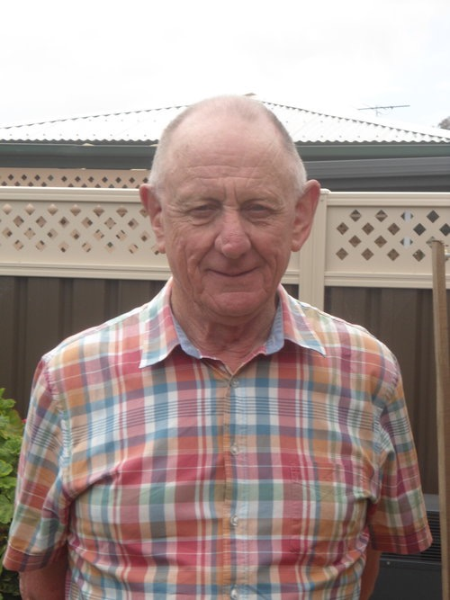
Arthur was first roped into playing bridge when his parents and aunt needed a fourth player.

Previously a bridge supervisor at the South Australian Bridge Association, Arthur began teaching to attract new members to the Glenelg Contract Bridge Club.

"Member numbers were starting to dwindle as we have a very large number of elderly members so I volunteered to start teaching Bridge to help rectify this situation," Arthur said.

"This program has been successful with a number of people who have attended my classes now playing bridge at our club and at other clubs.

"I get most satisfaction out of seeing people that I have taught enjoying playing what I believe to be the greatest card game of all; Contract Bridge.

"By the way Mum and Dad still play three to four times a week at Glenelg. Dad is 96 and Mum 92. I am very proud of both of them."

When Arthur is not teaching or playing bridge, he enjoys overseas travel and going to the theatre with his wife.

"I have been happily married to my wife Beverley for 45 years. Beverley is not a bridge player which could be a good thing (LOL). We have two adopted sons, one from Indonesia and the other from Korea, and one granddaughter."

(Published on the Joan Butts website when Arthur became an accredited teacher)

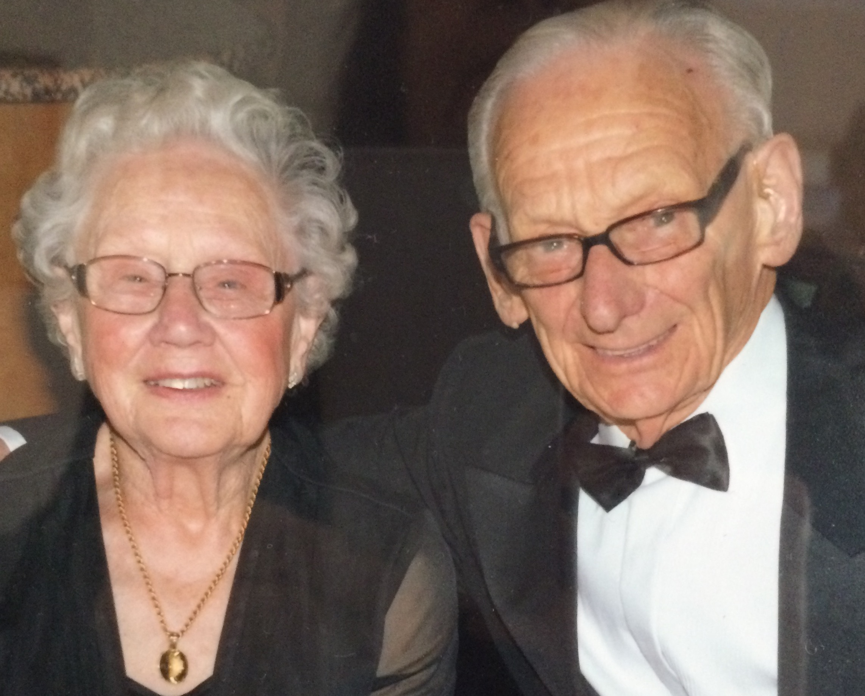
Members’ Profile
Audrey and Arthur Porter

Our heartfelt congratulations go to Audrey, 94 and Arthur, 98, who celebrated their 75th (Platinum) Wedding Anniversary in January this year. They are the oldest members of Glenelg Contract Bridge Club, and possibly the oldest couple still playing bridge in Australia.
Audrey and Arthur Porter would have to be the most well known and loved couple at Glenelg Bridge Club.
Audrey was born in 1924 in Croydon, South Australia, one of three children, who at the age of 13 moved with her family to Wollongong, NSW, in search of work during the Depression years. She joined the Women’s Auxiliary Air Force, the WAAF, in 1942 and was posted to the RAAF base at Richmond, NSW.
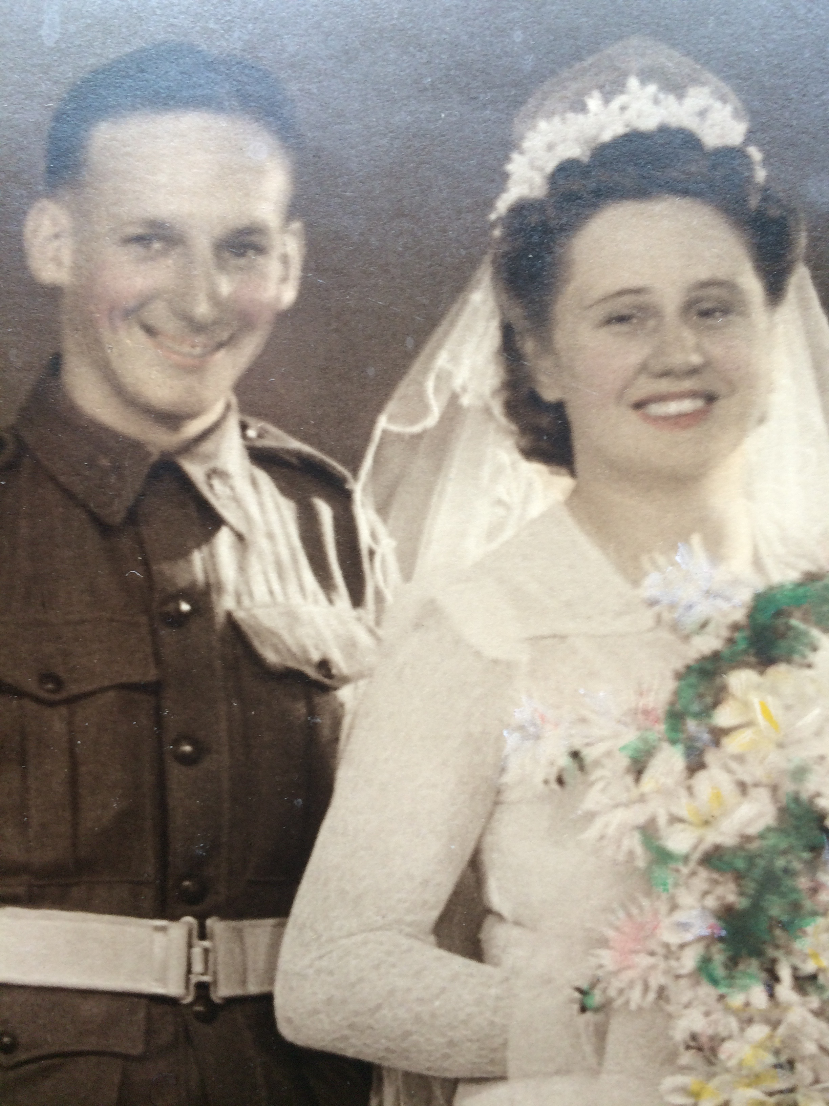
Arthur was the 6th of 7 children and was born in 1920 in Laura in the mid-north of South Australia. He was a good student and enjoyed learning. He completed 4 years at Gladstone High School, quite an accomplishment in those early years. He related and interesting story of how he made some extra money in 1937 sewing wheat bags in his holidays . He was paid 11/2 d a bag, 12/6 for 100bags and one day his record was 150 bags for 18/9 working from 6 am to 7.30 pm. He was a very tired and sore boy that day! Arthur went on to begin his 46 years at the Tramways in Adelaide in 1938, going from a junior clerk to the Finance Manager when he retired.
During the war he was in the Paratroopers and was stationed at Richmond RAAF base when he met Audrey in 1943. They married in January 1944 in Sydney and in December of that year their first child, Arthur, a long-time President of our club, was born. Arthur was in Darwin when the Japanese started bombing in February 1943. Ships in the harbour, the post office and the aerodrome were bombed. Strategically, the camps were not bombed. He was in the Army for just under 5 years and did 13 jumps in total. Arthur went back to the Tramways after the war and worked there until 1983, when he retired.
Audrey has been a tireless volunteer throughout her life, working with Meals on Wheels for 35 years, making sandwiches at St Andrews Church for 20 years and in church basketball for 35 years. She received the Paul Harris Fellowship from the Rotary Club for outstanding service to the community. She was also Treasurer at Glenelg Bridge Club for 11 years. Arthur was Club President for 1 year. Audrey and Arthur began playing Bridge in earnest after Arthur retired, with Audrey having played for 29 years and Arthur longer. They are both National Masters with 2 stars, a great achievement.
They are very proud of their son and daughter and their 4 grandchildren. During their retirement, they have enjoyed many cruises and bridge cruises. Audrey and Arthur are very happy and enjoying life together. They say the highlight of their life is their 75 years of marriage.
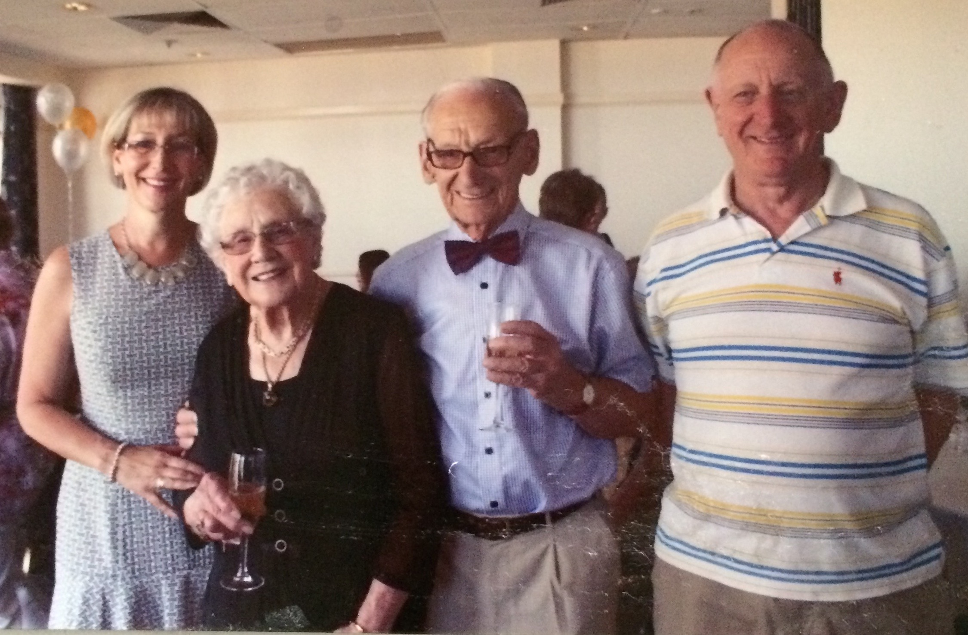
Thank you to Audrey and Arthur and happy anniversary!

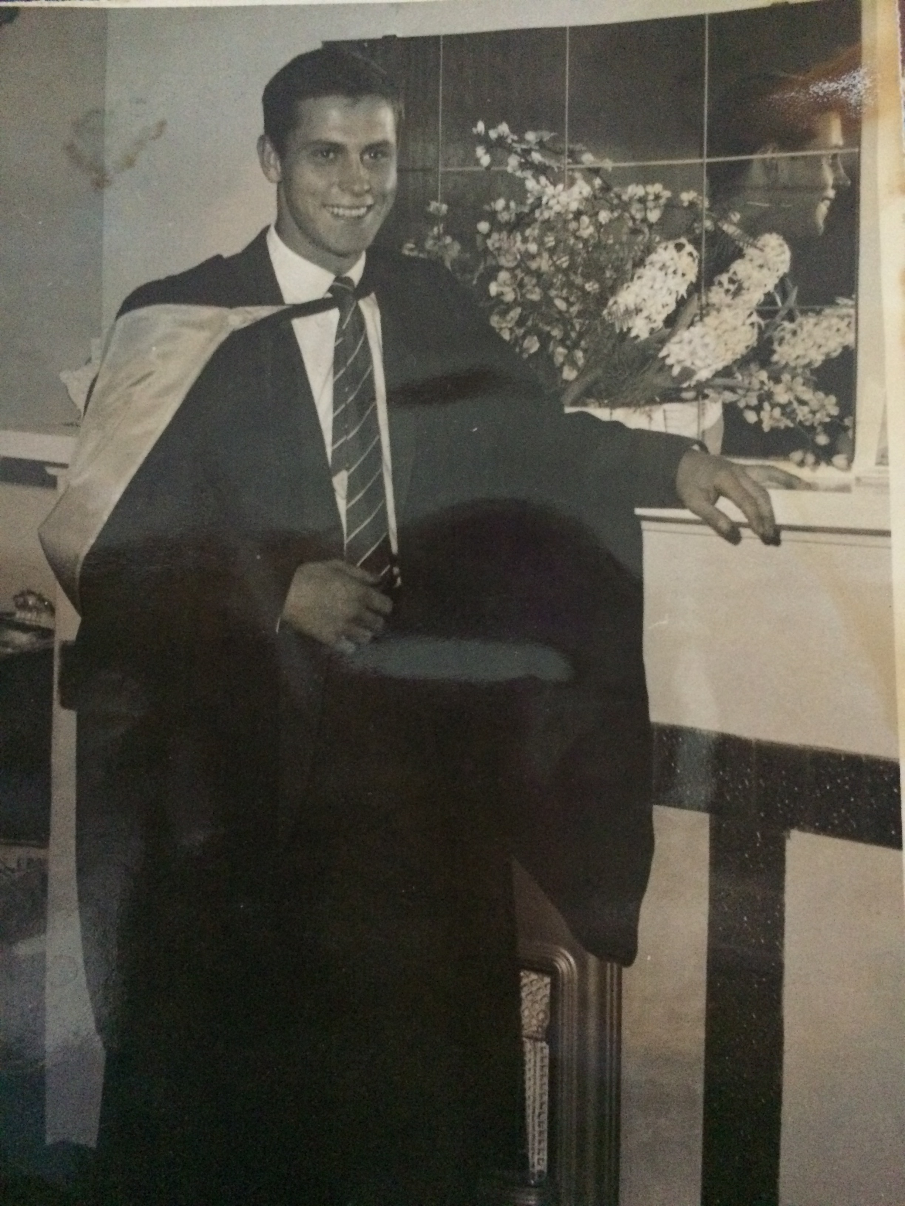
Member Profile -Peter Teubner
I recently spent a fascinating hour getting to know Peter Teubner a little better. He is always the happy, smiling face who says boldly “Welcome to Our Table!” on a Tuesday afternoon for as long as I have been playing bridge.
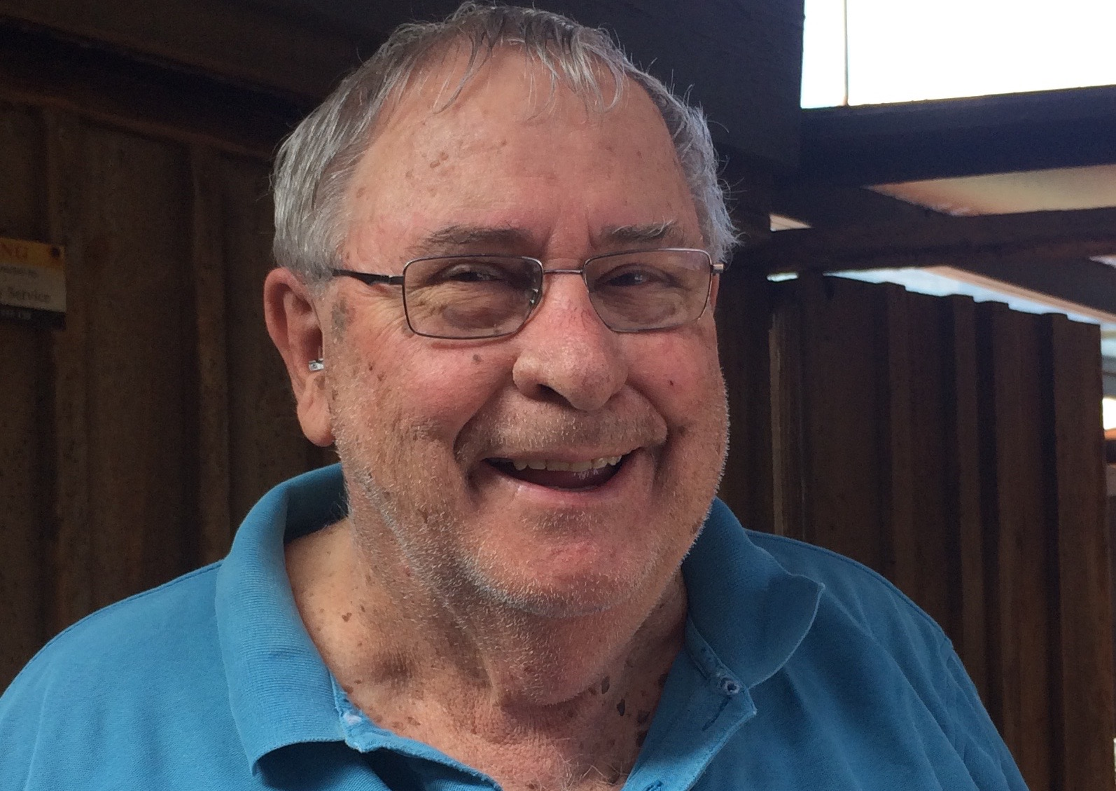
Peter was born in Coburg, Melbourne in 1940 and as a young child moved with his family to live in Kangarilla, South Australia, the birthplace of his mother.
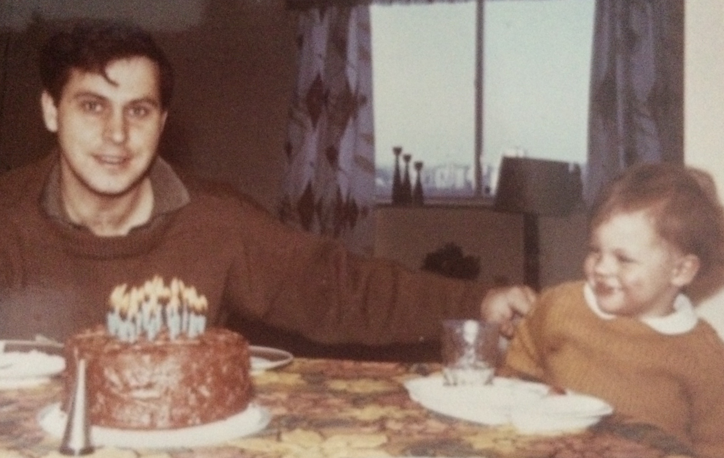
He went to Kangarilla Primary school and then went to Adelaide Boys High School. At the end of his Intermediate Year, he was awarded a Teaching Scholarship, a small stipend which allowed him to finish the final 2 years of high school and then to be the first in his family to go on to a University education. At Adelaide University he studied for a Science Degree and Diploma of Education at Adelaide Teachers’ College. It was here that he met his future wife Jillian, on Valentine’s Day 1959. Peter went on to do his Honours degree in Science and graduated 1960. When Jill told him that she was going on to do her PhD in Organic Chemistry, he decided not to be outdone and applied to do his PhD in molecular physics. They married in 1964.
In 1967, the young family, with 2 year old David, moved to the University of Pittsburg, USA. His second son, Jonathan was born there and after he completed his doctorate, they moved back to Adelaide and Peter took up a post at Flinders University, first as a lecturer, then as a Professor. After his retirement in 2005, Peter was awarded the prestigious Emeritus Professor of Physics. During his time at Flinders he established a world recognised group in the field of electron scattering from atoms and molecules and he convened an international conference on the topic. He was made Fellow of the American Physics Society in 2000.
Jill was also an outstanding scholar and was the first Australian woman to be awarded a PhD in Organic Chemistry from Adelaide University.
He believes that his legacy in life lays not in his degrees and awards but in his teaching, and the difference he has made to the lives of the many outstanding students he has mentored.
He is very proud of his 2 sons and his 3 grandchildren, Ali, Tom and Adela. He is an avid reader and often writes reviews for the club newsletter, introducing us to a wide range of books.
One of the other things Peter was introduced to at Flinders University was bridge, and he continued to play bridge socially with people like Phil Gue and David Askew during his student and teaching days.
After retirement he joined Glenelg Bridge Club, becoming president from 2010 to 2013, and was awarded life membership in 2015. He now plays 3 times a week: at SABA on Monday night, Glenelg on Tuesday, and Sue Phillips’ on Friday. When asked for his tip for beginning players he said that the best thing was to start off simply.

Thank you Peter, I look forward to joining you at your table every Tuesday .

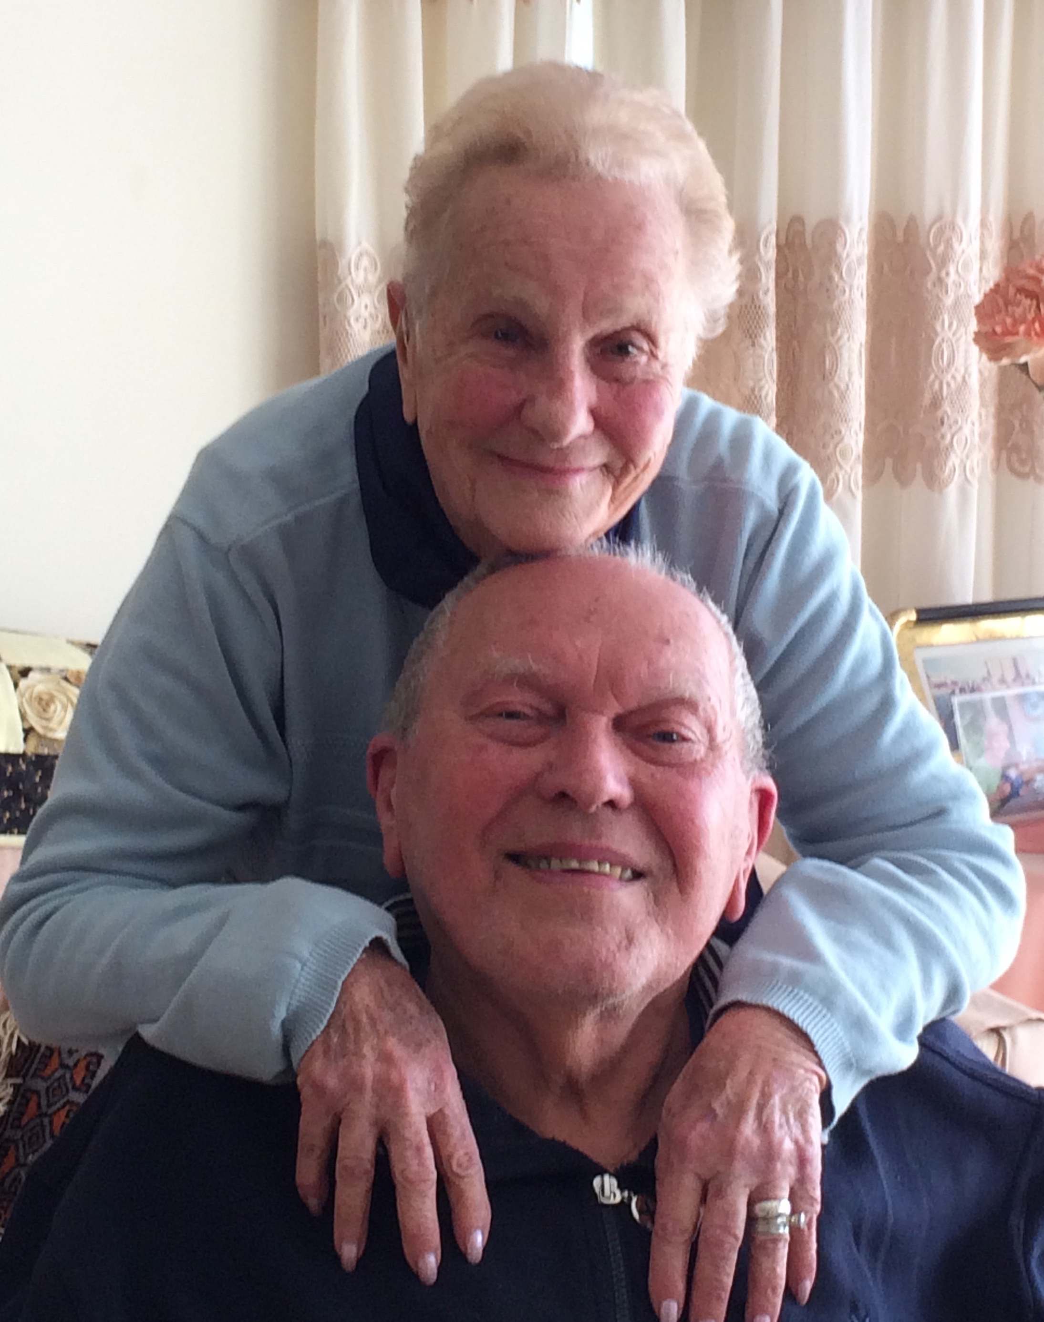
Members’ Profile Rina Belleli and Eddie Skala

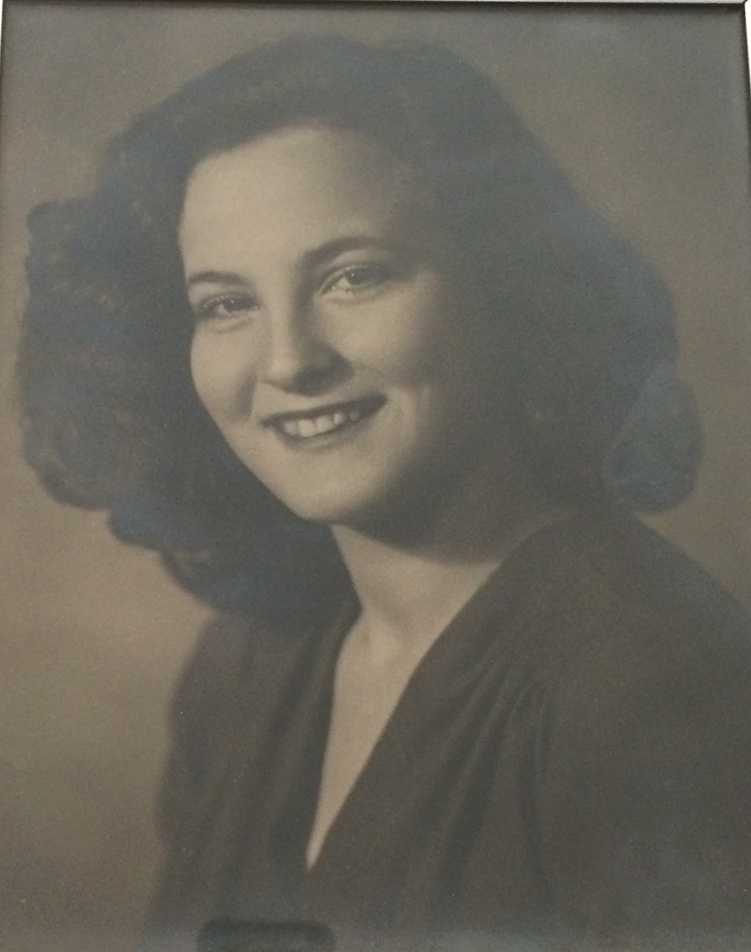
Recently I spent a very interesting afternoon with these two lovely members who have played bridge at the Glenelg Bridge club since 2001, in our Partridge House days.
Rina was born on Jan 5th, 1930 in Alexandria, Egypt. She had 2 brothers and her grandmother, who spoke only Greek and Italian, lived with the family. She attended the French School in Alexandria where she also learned a little English. Her memories of her childhood are dominated be the night bombings of Alexandria during WW2. Until the age of 8, Rina and the son of family friends Nado, were great playmates. He moved away and when they met again, when Rina was 15 and a half years old, it was love at first sight. They married when Rina was aged 17. Two children later, in 1957, they were forced to leave Alexandria because of the Suez War and they went to live in Brazil. They lived in Sao Paulo for 11 years where she worked as a secretary and now had to learn Portuguese. She also had her 3rd child, a son, during this time. In 1968, Rina with her family came to live in Adelaide as her brother and his family were living here. She worked as an interpreter at the Commonwealth Bank where her knowledge of 5 languages stood her in good stead. She has 5 grandchildren and 11 great grandchildren.
She loves travelling and has been on 15 cruises, as well as many land trips. In October Rina and Eddie plan to cruise up the east coast of Australia to Queensland. Her other hobbies include crosswords and of course, bridge, which she plays 3 times a week at Glenelg.

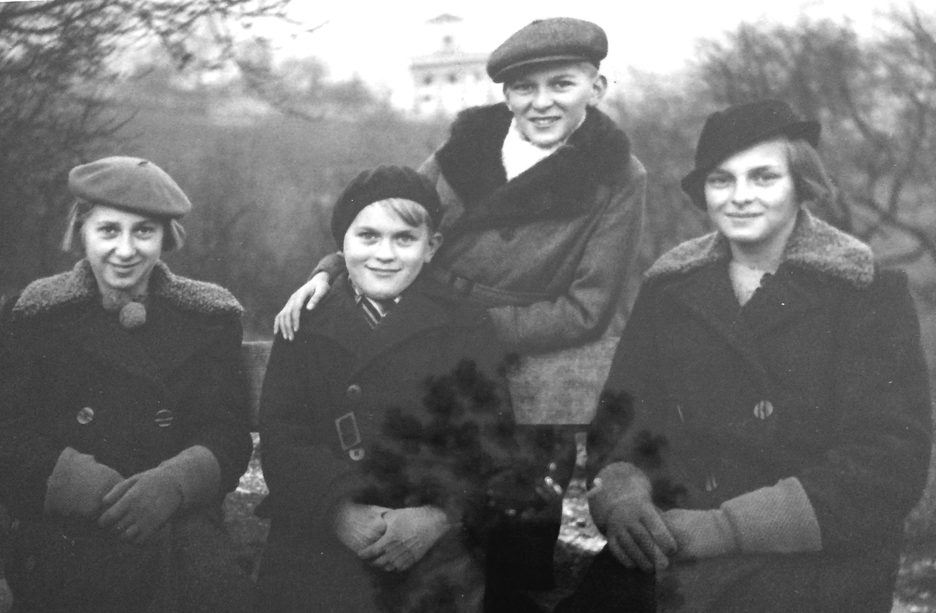
Having recently celebrated his 90th birthday, Eddie was born on July 17,1928 in Czechoslovakia, near Prague. He was the youngest of 4 siblings with his remaining sister still living in the Czech Republic, aged 96.
One of Eddie’s strongest memories of his youth was attending school during the war years for only one day a month during the freezing winters when coal and fuel was scarce. At age 14 Eddie left home and began training as a waiter and cook but was conscripted as forced labour to help dig trenches for the German Army as it retreated in the final days of the war. He managed to return to Prague on the crowded roof of a German Hospital train. In 1949 Eddie was conscripted again, this time into the Army of the now communist Czechoslovakia. He knew this was not the future for him and, at his first opportunity, made his way to Bavaria with some friends. Eager to escape the turmoil of post war Europe, they met an agent who was paid 10 Deutsch Marks per head for any man he was able to deliver to the French Foreign Legion in Strasbourg. After qualifying for officer training, Eddie’s career as a legionnaire was cut short when they marked him as a communist due to confiscated letters from his father who was in Czechoslovakia. On the road again, and still in army uniform, he was taken into the British Army and worked in the Officers’ Mess in Hanover. Looking for a new life, Australia was one of the only options for migration available to him and in 1950 Eddie arrived by ship in Fremantle with only the clothes on his back.
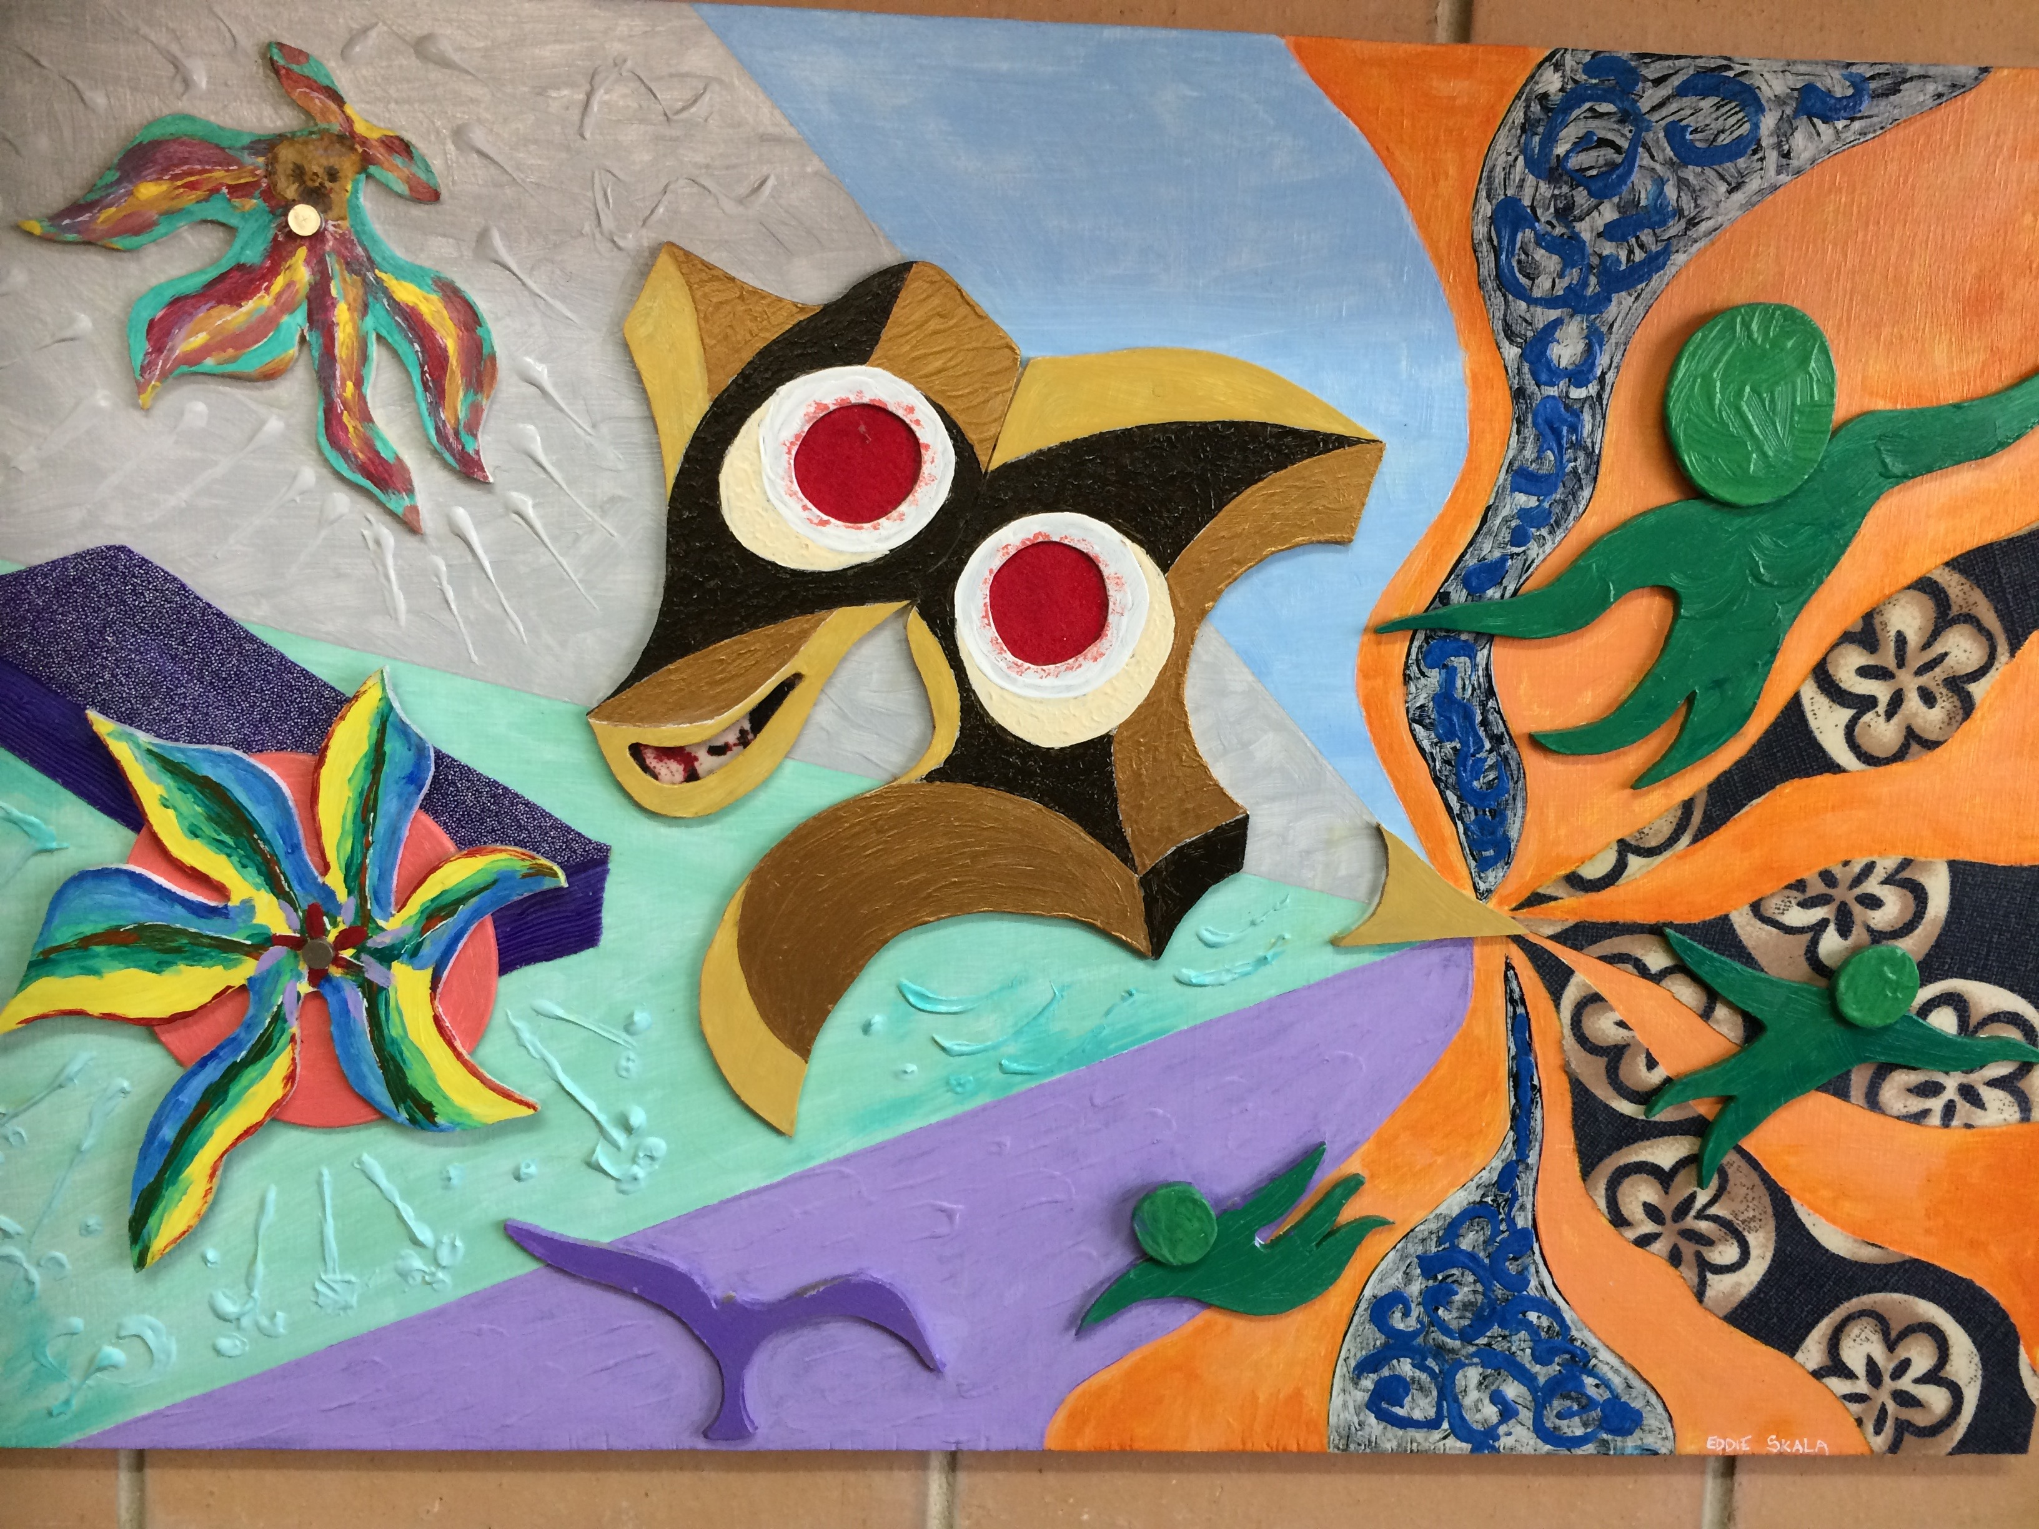
Contracted to work for the Australian Commonwealth for 2 years, Eddie worked on the railway between Quorn and Alice Springs and during this time, while on leave in Adelaide, he met his future wife at Glenelg Beach. Diva was born in Izmir, Turkey and grew up in Cairo, Egypt. Eddie and Diva were married in November, 1952. Eddie had a snack bar in City Cross from 1964 until 1970 and then a menswear shop in Gawler Place from 1970 until 1982. 1994 was Eddie’s first return to his home country and the first time he had seen his sisters for 44 years. His hobbies include travel, crosswords and painting which he took up in his retirement. He paints in many different styles and mediums and is very accomplished. Below is one of his abstracts.
Eddie and Rina had played bridge socially with their partners with a group of 8 people for 35 years, playing 2 tables at a different couple’s house every Sunday.
After the deaths of their respective partners in 2001, Rina and Eddie decided to further their friendship, to keep each other company in life and as travel companions and continue as bridge partners.
Thank you Rina and Eddie - there is so much more to your stories and we are grateful that you shared some of them with us.

June Hammond

Member’s Profile - Peter Williams
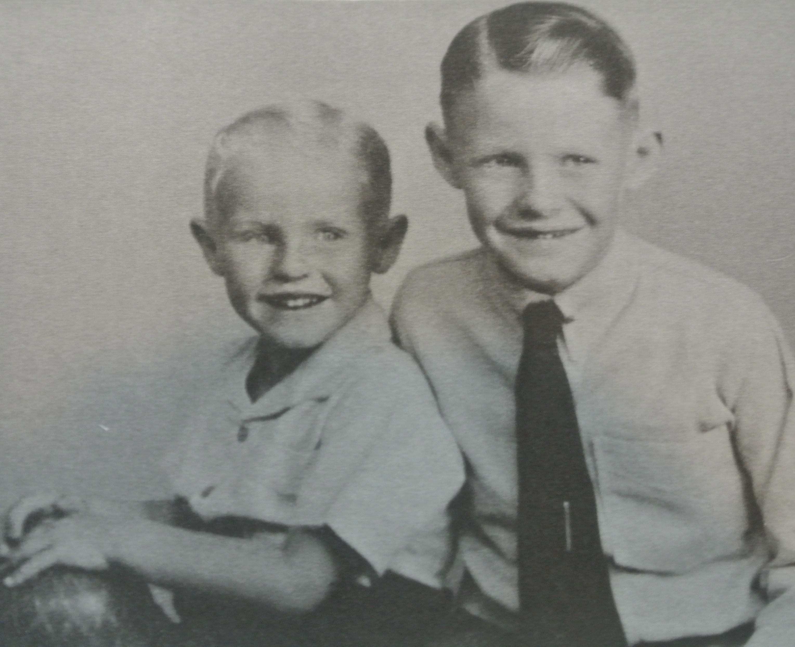
Peter was born on Good Friday, March 30, 1945. His parents lived in Prospect, his father being a self-employed men’s hairdresser, and Peter was the middle child, having an older brother, Roger, and a younger sister, Helen.
Peter went to Prospect Primary School and followed his brother to Adelaide Boys’ High.
One of his most vivid childhood memories is winning £85 (more than $2,500 in today’s money) on 5DN’s “Aspro" Hit Parade Show. Listeners had to predict the upcoming “Top 8” and Peter clinched it by predicting the return of Frankie Avalon’s “Venus”.
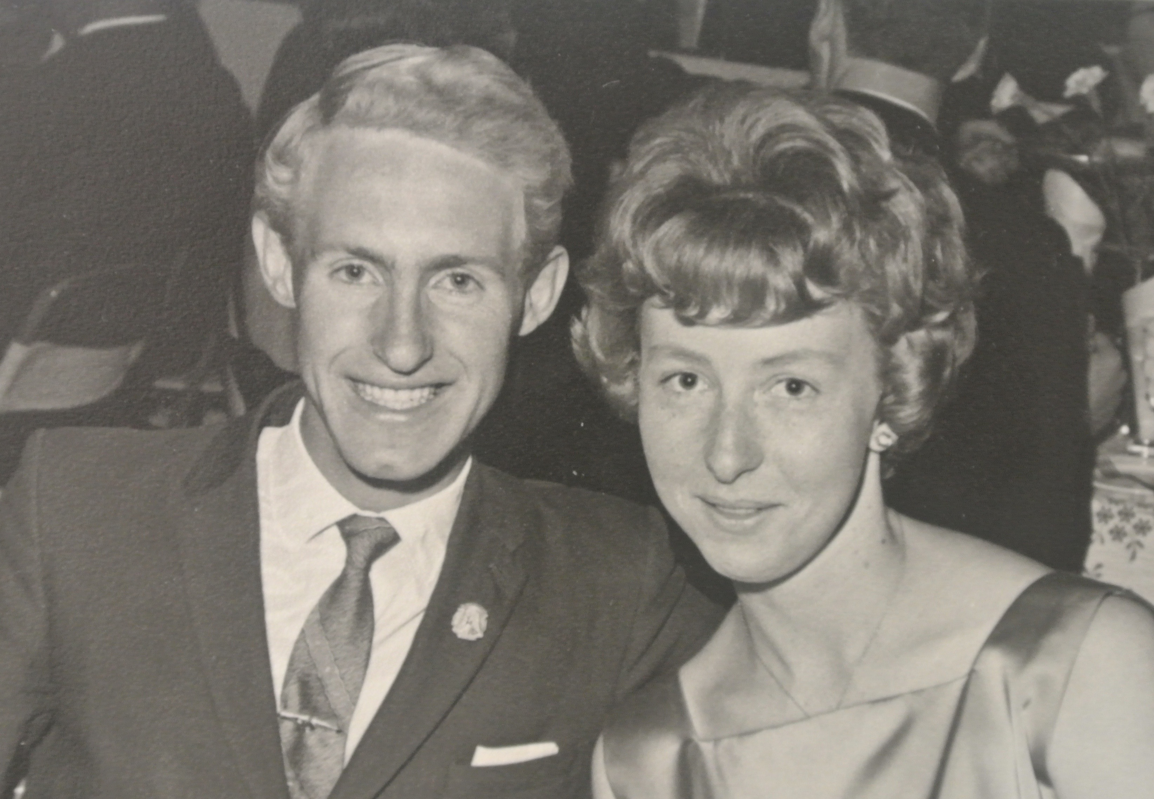
He studied Maths & Science at Adelaide Uni and Teachers’ College, and while still at college he married Leonie, who was studying to be a primary school teacher. They hadn’t met at lectures but at dancing classes, and they were no slouches, winning several medals for ballroom dancing.
Peter spent his first 3 years teaching at Nuriootpa High School which he loved.
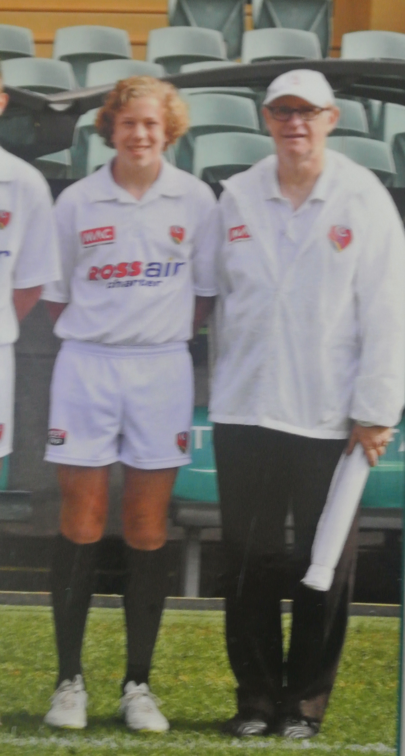
A further 5 years at Northfield High wasn’t as palatable, due to the different attitudes of the students and parents, and he realised that he had reached a turning point. His time at Northfield did have some positives however, as it had introduced him to bridge, and he learned to play at SABA, then in Currie Street, in the early 70s. In 1974 a trip to the Sydney Bridge Shop led Peter to a make brave decision. He was offered the Adelaide agency for the shop and he gave up teaching for 2 years to see if he could make a go of it. By incorporating bridge teaching and directing, and with the support of Leonie, Peter made bridge his vocation.
He started the Modbury Bridge Club at his own home, followed by a club at Kensington, and became a member of both Walkerville and Glenelg Clubs. This makes Peter one of the very early members of Glenelg Bridge Club, which was then still meeting at the Glenelg Town Hall. He was the club’s full time director for many years. His description of the director’s duties before the days of dealing machines and computer scoring, is fascinating for those who, like me, have come to the game more recently. At the first table the cards were dealt and, after the hand was played, the scores and the hands were written on the “traveller”. The collating task for the director was all manual and much more demanding than it is today.
Peter was happily married to Leonie for 20 years, having 2 sons, James and Kevin, before Leonie sadly passed away in 1988. He married a second time to Barbara, whom he lost to illness after a 20 year partnership. His current partner is Thelma who patiently shares him with his other love, bridge.
Peter counts goal umpiring as another of his interests. He began umpiring at the age of 17, and, after 42 years, is still going. A life member of the Amateur League, he has just officiated in the country champs at Adelaide Oval. One day at Prospect Oval, during his years in the SANFL, he took “keeping your eye on the ball” a step too far and copped a split iris for his trouble. Incredibly, he was back umpiring the next week.
There are many in our club who will vouch for Peter’s ability to teach and mentor, and if you have ever thought that he looks at home in front of the white board, now you know why.

Graeme Hammond

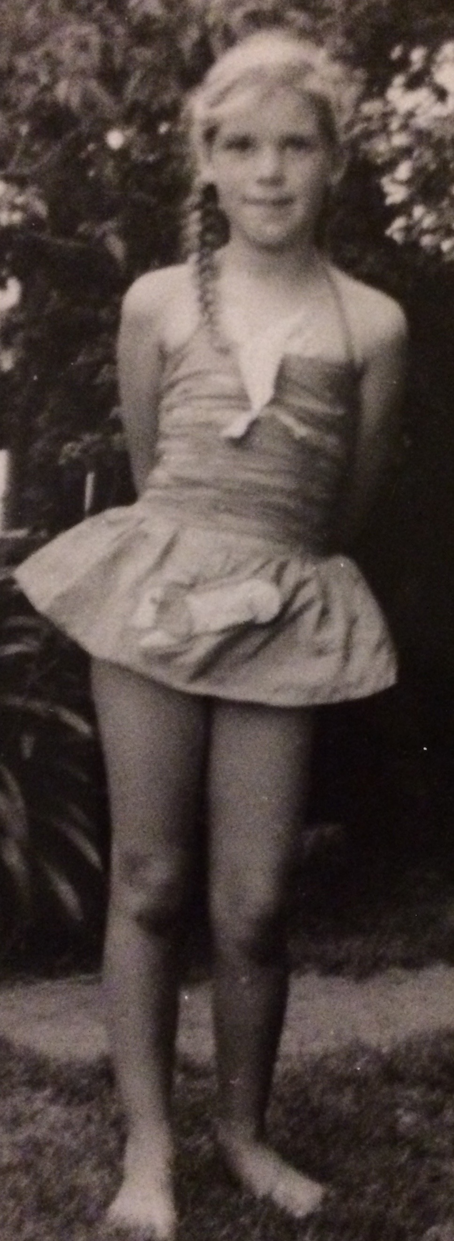

Member Profile - Sarah Mehuys

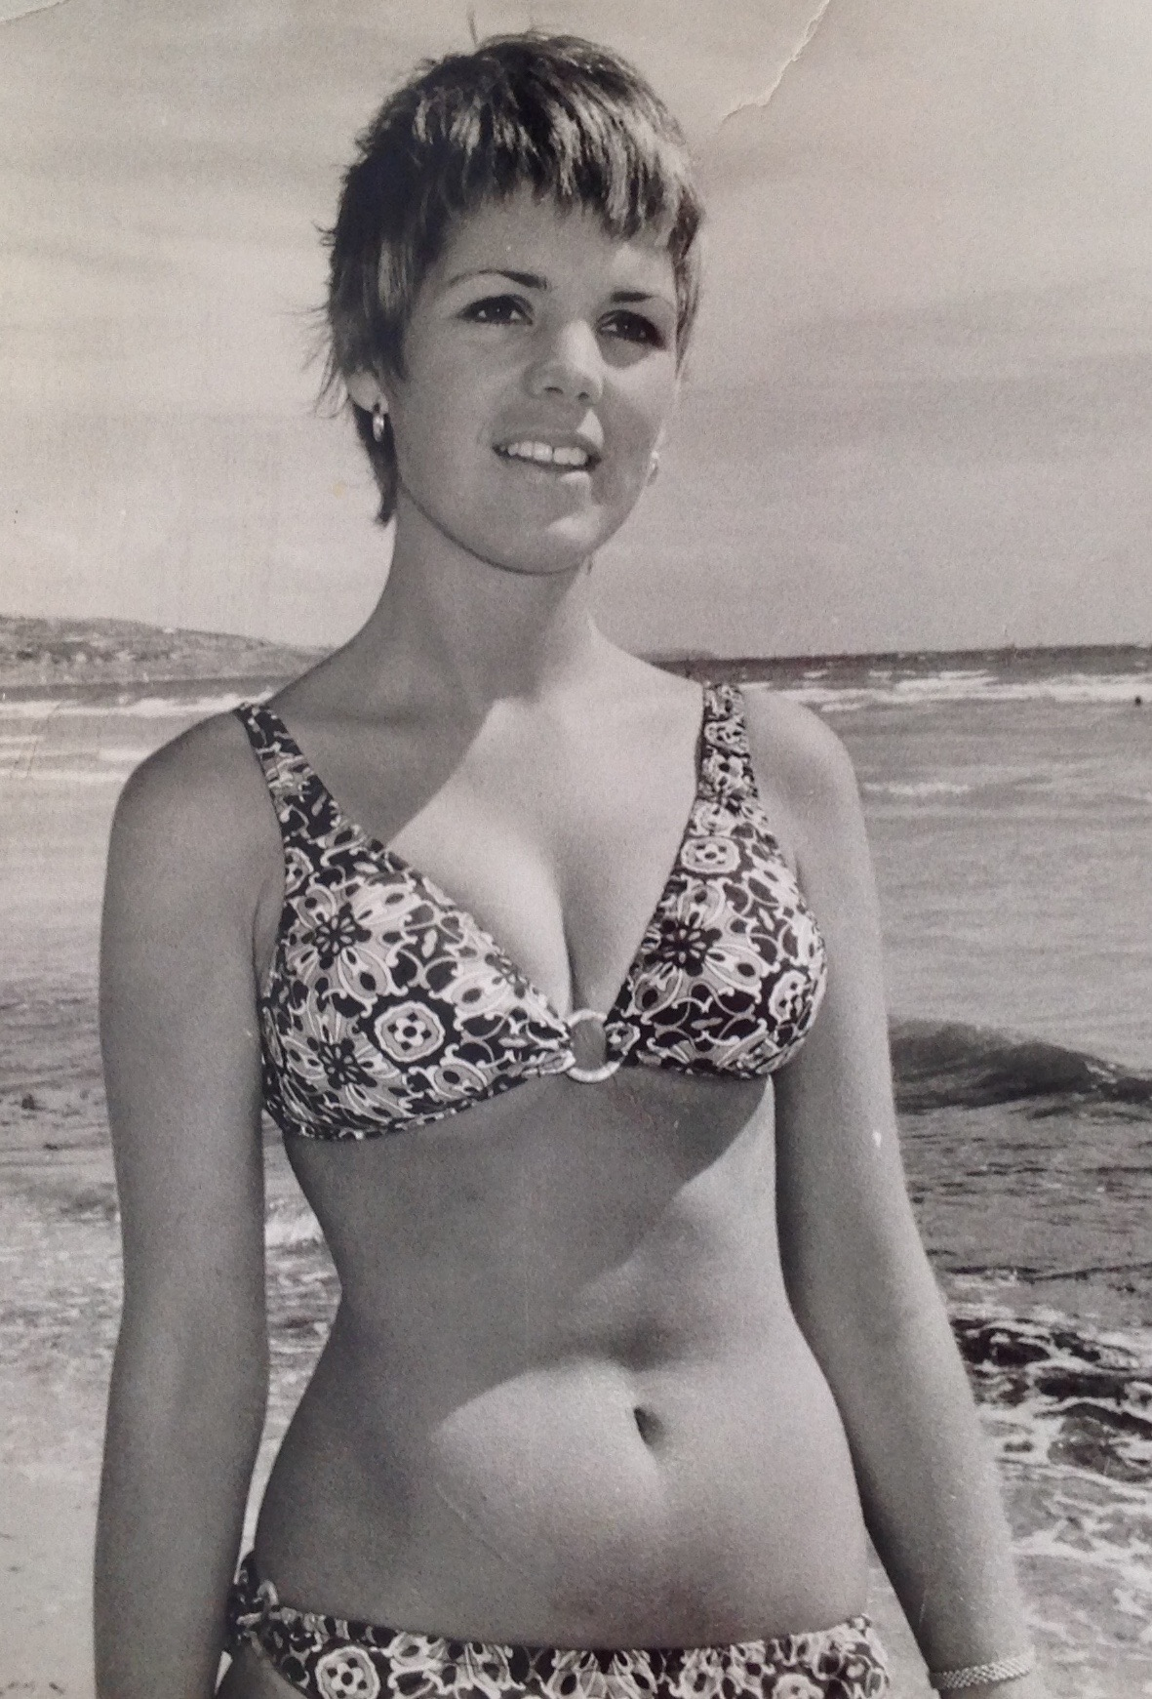
One of the new members of our committee, Sarah Mehuys was born in Stirling, South Australia in 1949. She was the youngest of three girls and as a youngster remembers spending time in hospital, being cared for by her parents because she was born,as was her oldest sister, with a hole in her heart. A move to Warradale was necessitated because of the many hospital visits and she attended Warradale Primary School and later, Brighton High School.
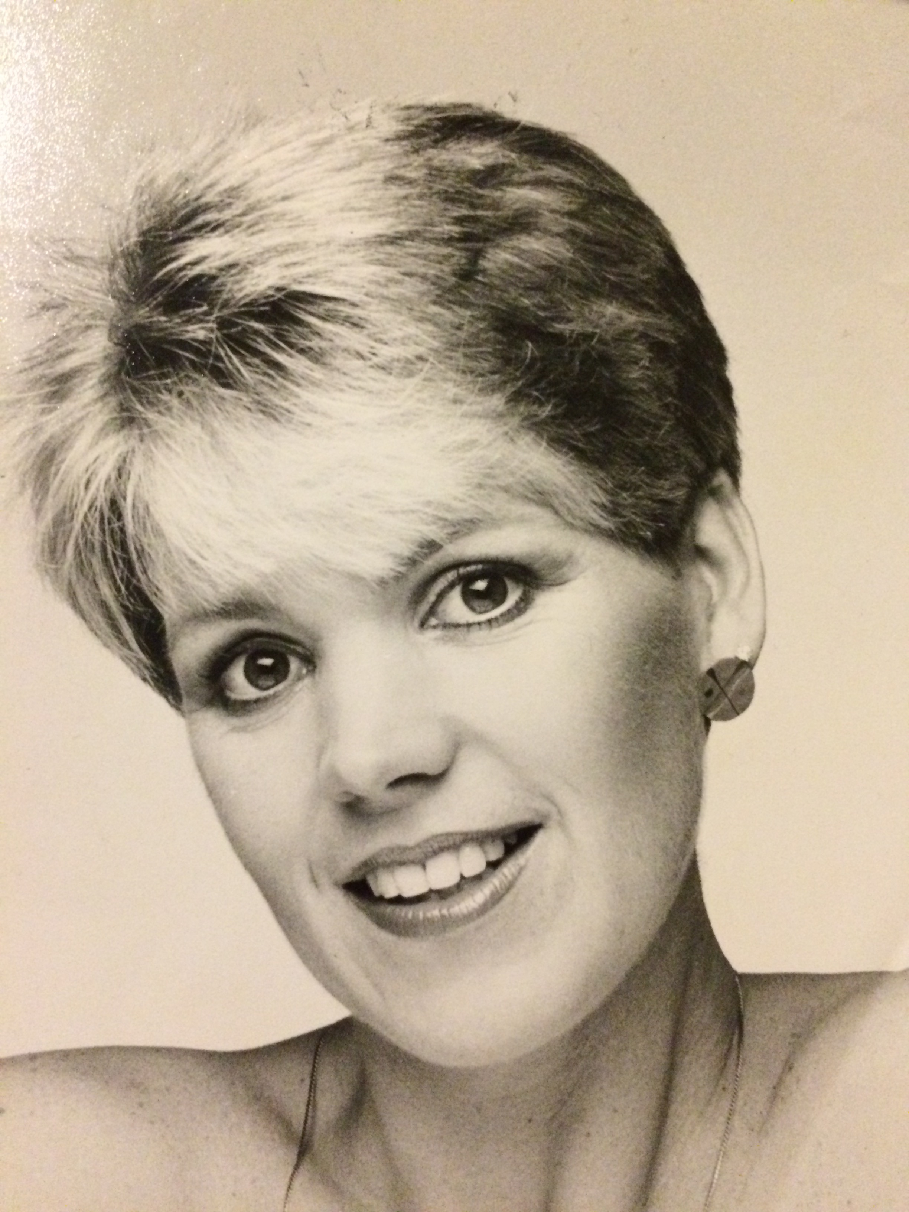
After school, she joined the AMP and worked there for 7 years. During that time, one of her work mates encouraged her to join her in one of the heats of the Miss Beach Girl competition which she promptly won, much to the chagrin of her friend. She went on to be a finalist in the competition.This was to be the beginning of a long and successful career in fashion and photographic modelling which Sarah went on doing for a further 30 years. She also performed in the AMP Theatre group, on Adelaide Tonight with Ernie Sigley, made many television commercials, one with Olivia Newton John, & met Stevie Wonder, Joan Collins, Ayrton Senna, and Elle McPherson. She appeared on Touch of Elegance weekly for many years modelling clothes, and has acted in bit parts for a couple of Australian films. Her career was mainly photographic and as she was a little short for modelling, she would sometimes stand on phone books! Hence all is not what it seems with photography. In 1975 she was also nominated for Photographic Model of the Year. One of the more notable companies Sarah worked for was Woodcock Reynella established in 1930. Sarah worked for them for 30 years. It is still trading to this day, a leading fashion emporium with haut couture and designer-wear clothing at the highest end.
Sarah was also a very accomplished squash player, playing at State level from the age of 18 until she was 54, when a snapped tendon meant the end of her competitive squash days.
A much more important highlight of 1975 for her, was the birth of her first child Lucy, and Lucy and Sarah went on to win Mother and Baby of the Year in South Australia. She modelled for John Martins, David Jones, Target nationally in their catalogues and Harris Scarfes amongst many other smaller customers. She even found herself being driven around the Grand Prix track on the bonnet of racing car driver Peter McLeod.
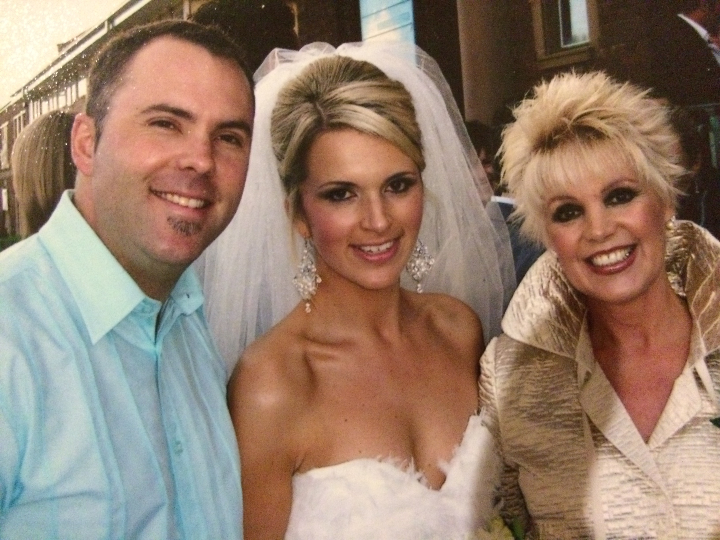
Sarah went on to become the South Australian and Northern Territory Manager for Arnotts Food Services.

Her son, Judd, was born in 1977. He also had a wonderful career in modelling because as a little boy he went with Sarah on many assignments and eventually modelled for John Martins, David Jones and Harris Scarfes, a joy to the photographers as he was so well behaved. It gave him a good start in life. He did this until about 13.
Her two children now have two children each of their own, and Sarah and Christian, her husband, enjoy spending time with their grand children.
In her spare time Sarah is passionate about her gardening, goes to fitness classes 3 times a week, loves walking with Christian and of course, playing bridge.
She and Christian have travelled extensively having had some amazing adventures walking through Morocco, Turkey, Africa, Sri Lanka etc as well as spending six months travelling around Europe. They go to France every two years to visit Christian’s family.

Sarah has been playing bridge for 12 years and tries to play twice a week at Glenelg Contract Bridge Club. Sarah’s motto for living life is “It’s not what happens to us in life, it’s how we deal with it.

I hope you have enjoyed getting to know Sarah a little better.

June Hammond

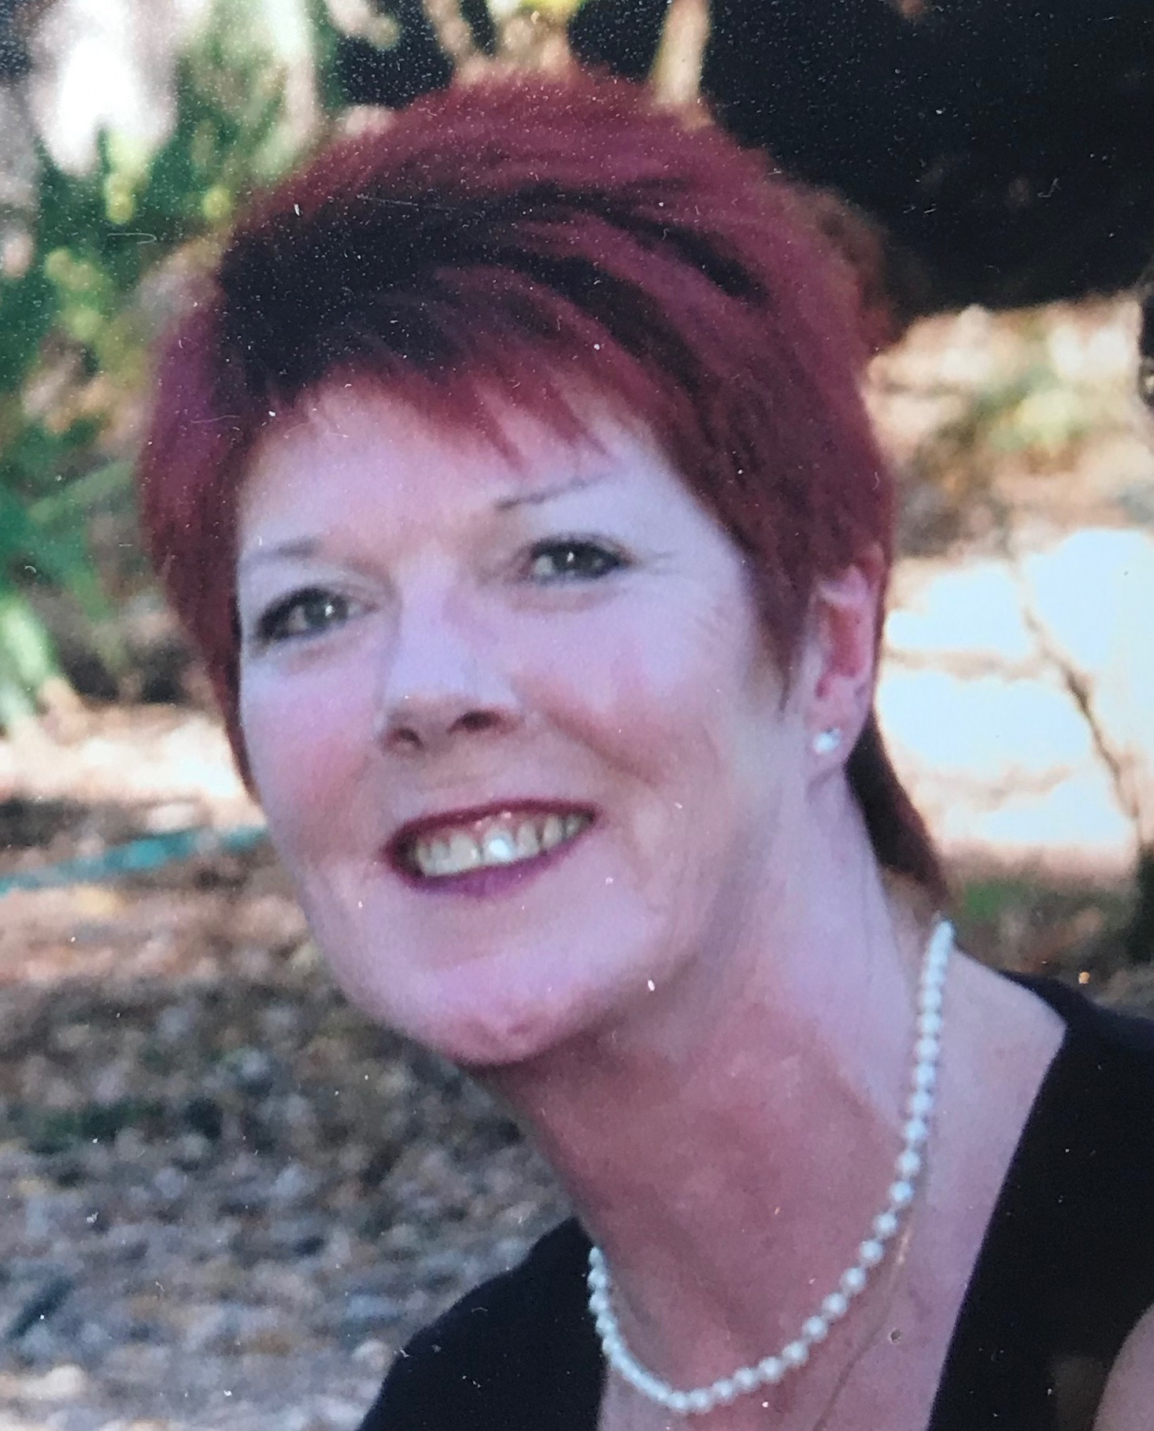

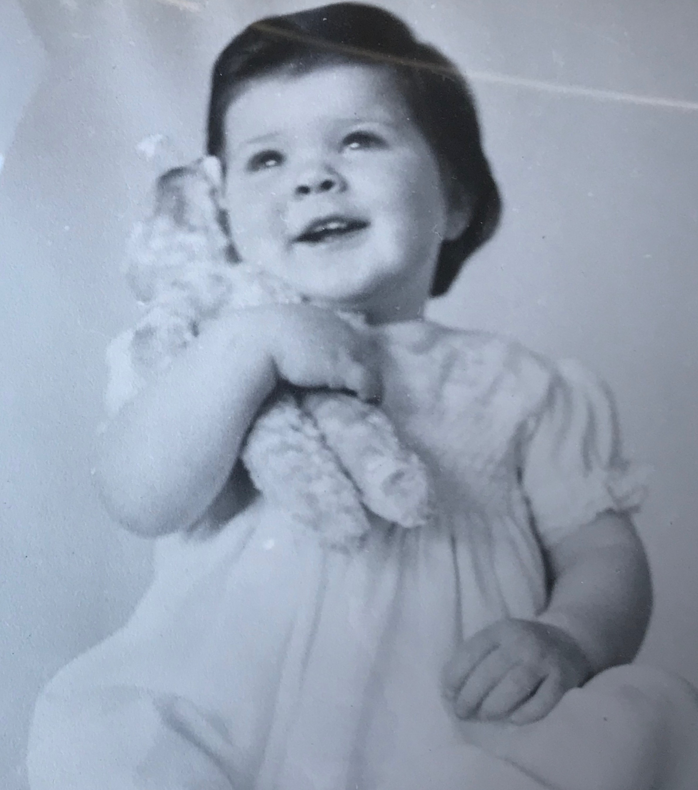
Member’s Profile : Julie Butler

Julie was born in Adelaide in August 1952, the sister of two older brothers. She grew up in Somerton Park and attended the local St Mary’s Memorial School in Glenelg and later Cabra College. She was a prefect, a very good student and sportswoman.

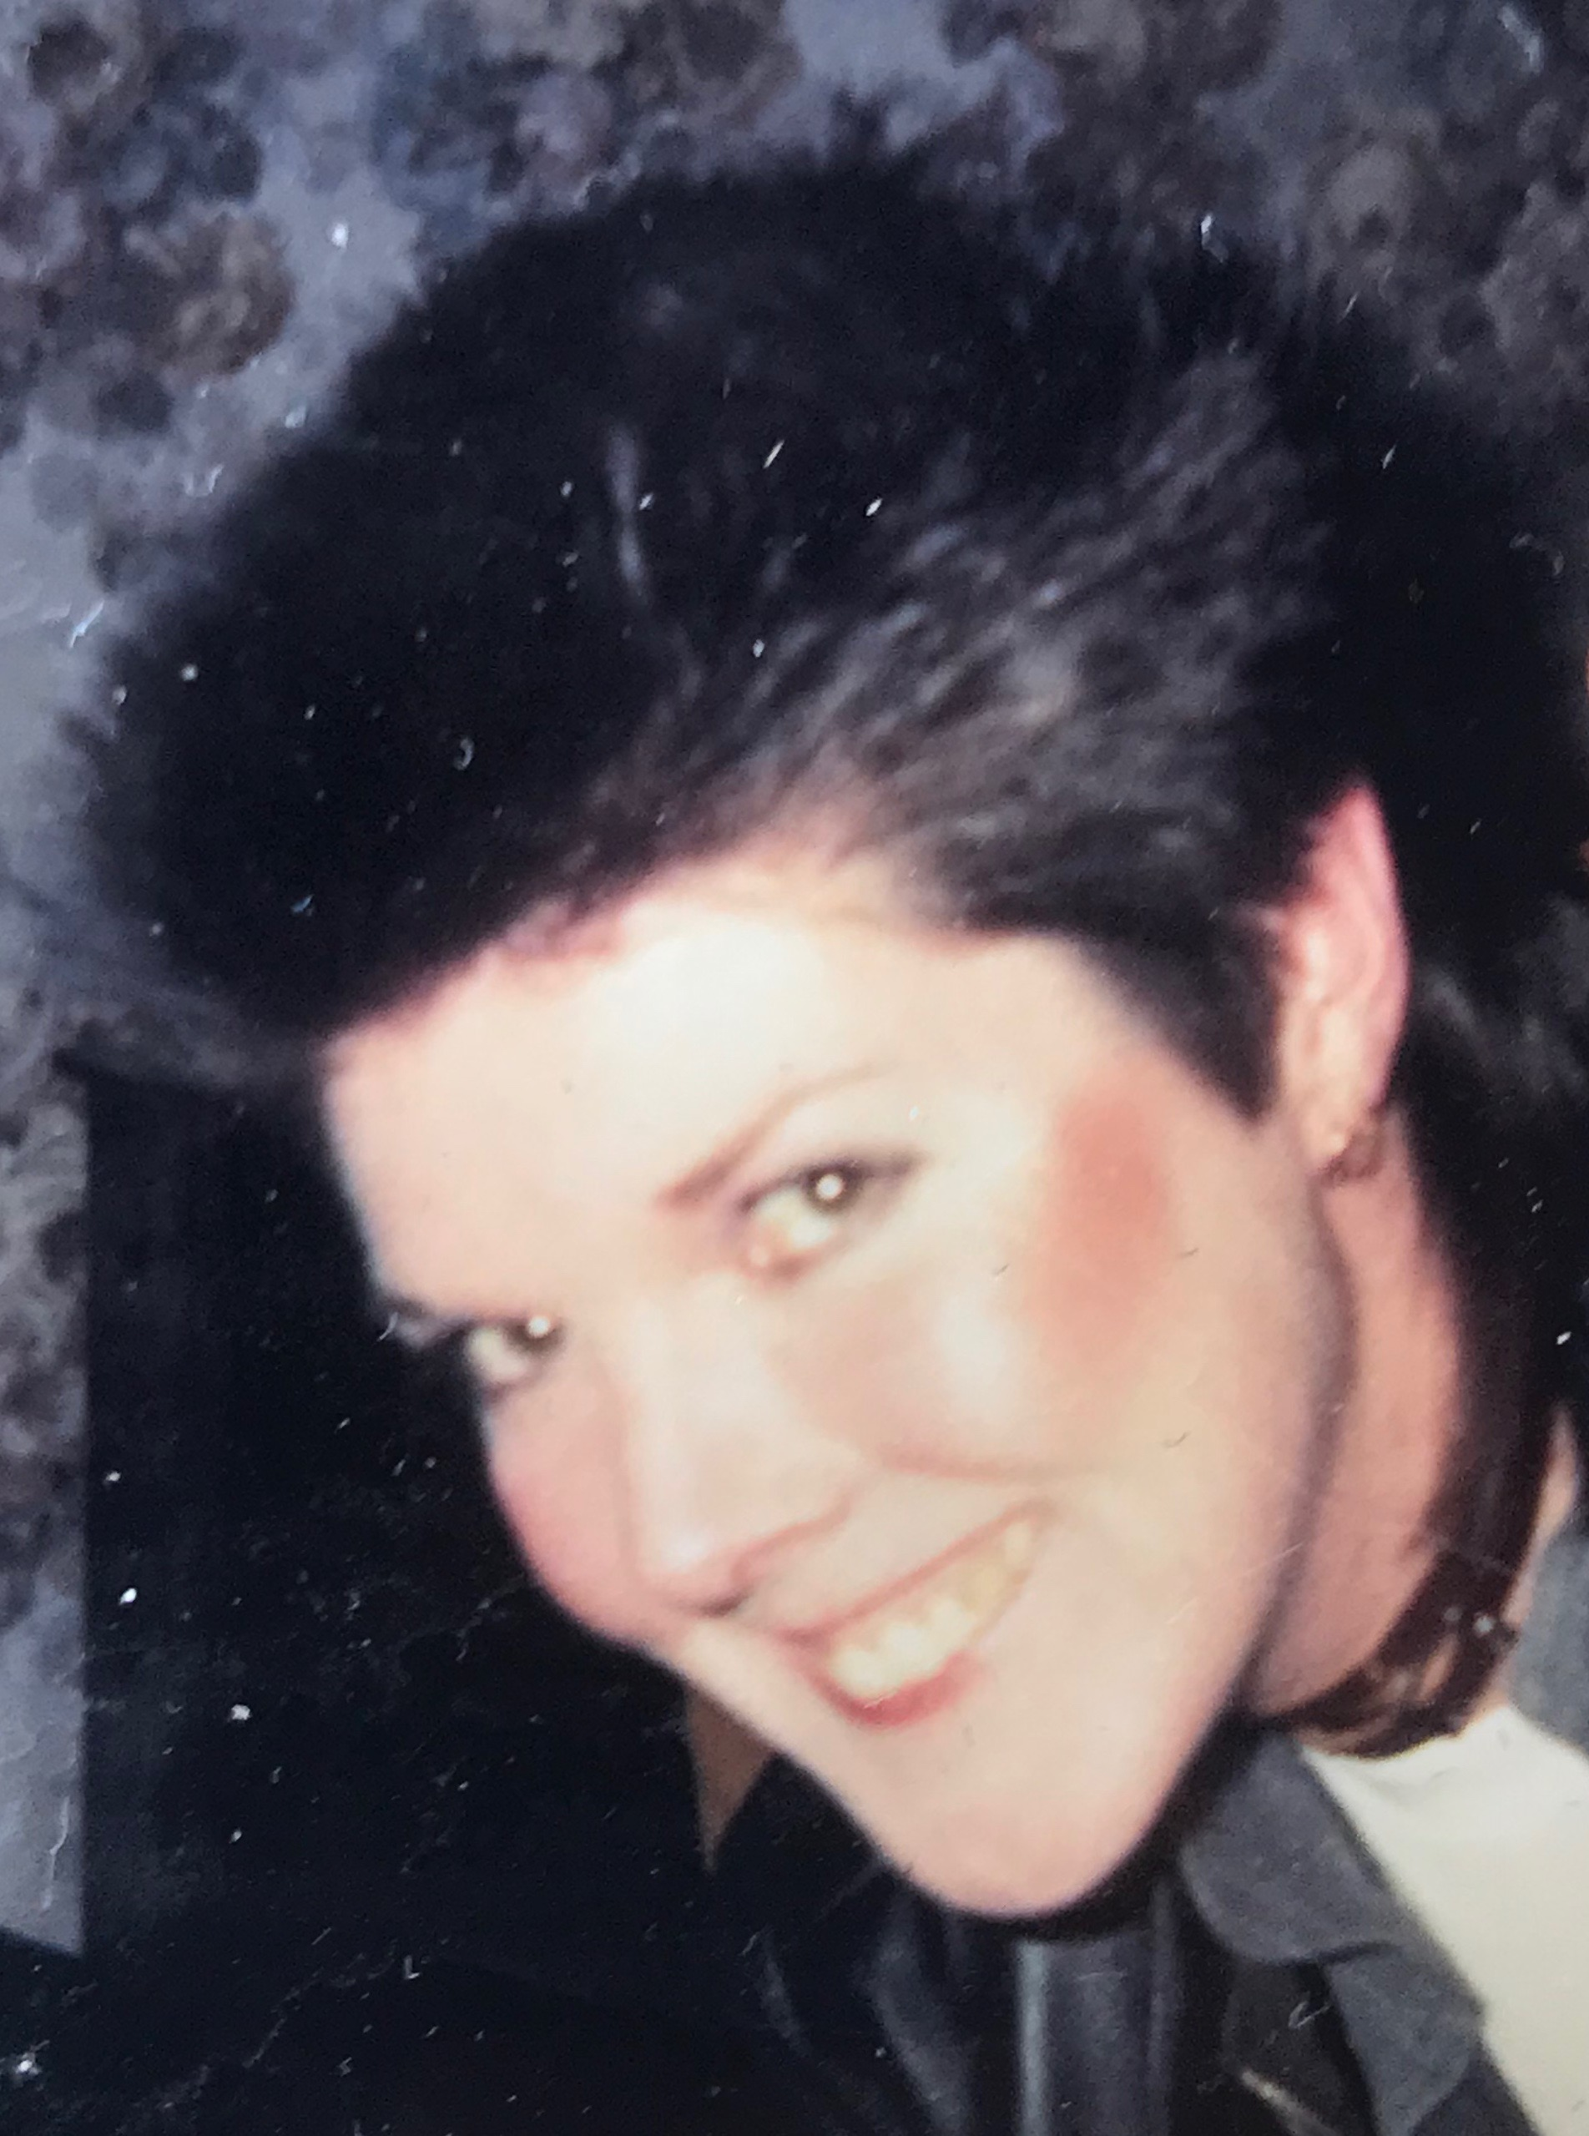
Her love of mathematics saw her achieving a degree in Mathematical Science with majors in Pure Maths and Mathematical Statistics. This lead to her career in computer programming and computer science, working in the Education Department and later as a lecturer of computing inTAFE.

She then went on to provide statistical human resources information and computer systems project management in the Australian National Railways before being whole-of-government Human Resources Systems Manager for South Australia Government.
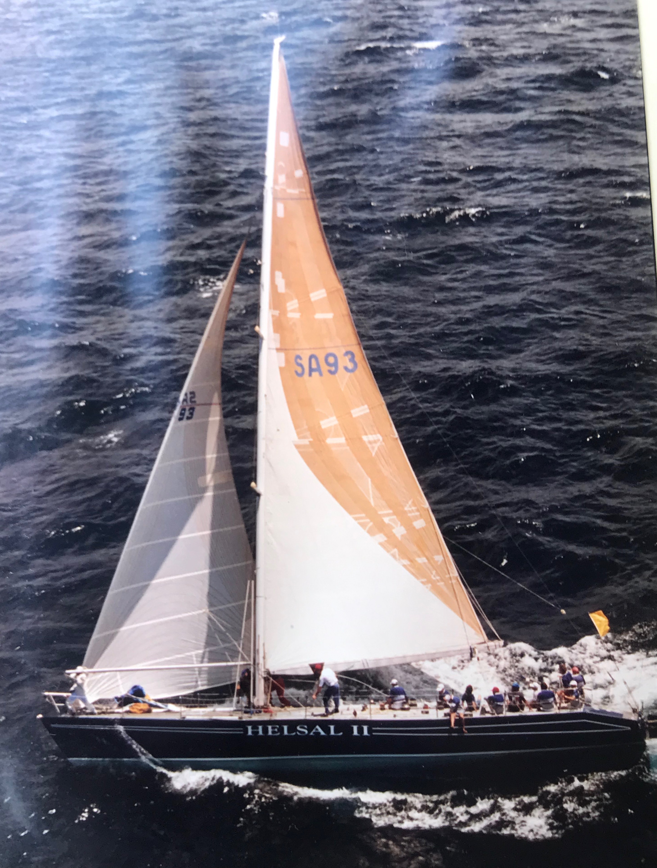
For nearly 12 years, Julie worked in South Australia Police as Strategic Human Resources Information Branch Manager and also conducted computer systems project management before retiring in 2012. After tutoring mathematics for a few hours per week at Adelaide Uni for 18 months, she decided to focus her attention on gym, bridge, meeting friends for lunch and her potentially perfect pooch, Hugo.

Julie has always been a very active person and has loved athletics, swimming, tennis, netball, golf and yacht racing. She has participated in 5 Sydney to Hobart yacht races between 1989 and 1998. She was one of the 18 crew aboard a 66 foot (pocket maxi) yacht named Helsal II. It was the most successful racing yacht in South Australia between 1988 and 2002. She was aboard this yacht when it endured and survived the 1998 Sydney to Hobart Race in which 6 men died. Their boom cracked during the storm and they had to complete the race without using the mainsail. There was a lot of damage to Helsal II and its crew members.
Julie has travelled widely throughout Australia and more than 60 overseas countries.

She finds helping people extremely satisfying, especially helping people learn.

Thank you, Julie. It has been great getting to know you a little better.

June Hammond

Member’s Profile - David Young

David was born in Mount Gambier in 1936 and it was at the Mount that he completed primary and secondary schooling.
After leaving school he worked for the ANZ bank, serving the bank for four years at the Mount, Adelaide, Naracoorte and Penola branches.
In 1957, looking for a career change, he left the bank and joined (as a Private) the Australian Regular Army, and was immediately sent off to the Recruit Training Battalion at Kapooka, near Wagga Wagga NSW, for 15 weeks basic army training. It was during this time that he met and married his wife, Yvonne.
Following this, was sent to the School of Artillery, at North Head near Manly NSW, for a further 16 weeks training in Artillery subjects.
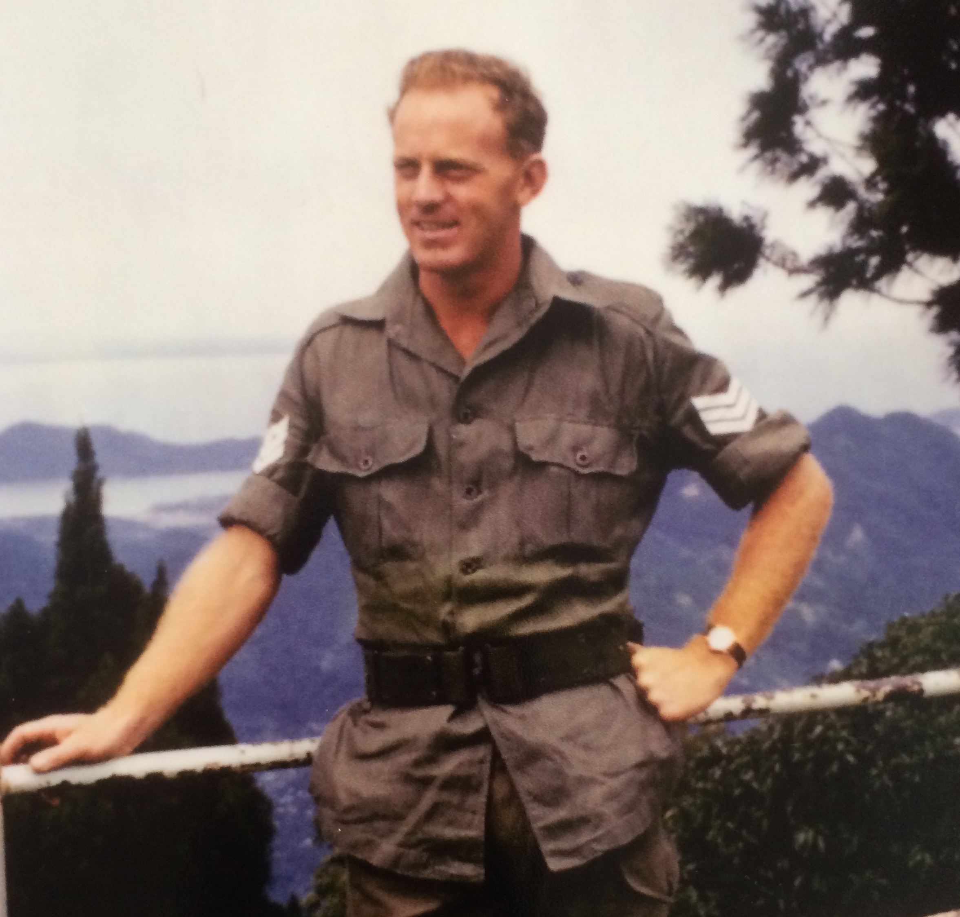
He was then posted to his regular unit 111 Light Anti Aircraft Battery, and for the next few years it was mainly unit training around Australia . However, during this period he was promoted Bombadier (corporal 2 stripes!) and was seconded to the Recruit Training Battalion, as an Instructor for two years. Again, he enjoyed this posting and its duties.
In 1964, due to confrontation between Malaysia and Indonesia, Australia was asked by Malaysia to provide military assistance in protecting the RAAF air base at Butterworth, near Penang Island. Australia responded by sending David’s unit to Butterworth for an initial 2 year period. During this time David was promoted Sergeant.
In 1965 David returned to Australia to attend an Officer’s course in Queensland and in May 1965 he was commissioned first Lieutenant and posted to a newly formed artillery unit 110 LAA Battery based at Holsworthy NSW, and later at Woodside SA.
In June 1966 this new unit relieved the Butterworth-based 111 Battery but this time families of the married men would also go. David was ordered to arrange for the movement, by air, of 50 wives and 85 children, to Penang Island and to have ready 50 rental homes to accommodate them. Each home was provided with a live-in Amah, which greatly pleased the wives (!) and a gardener.
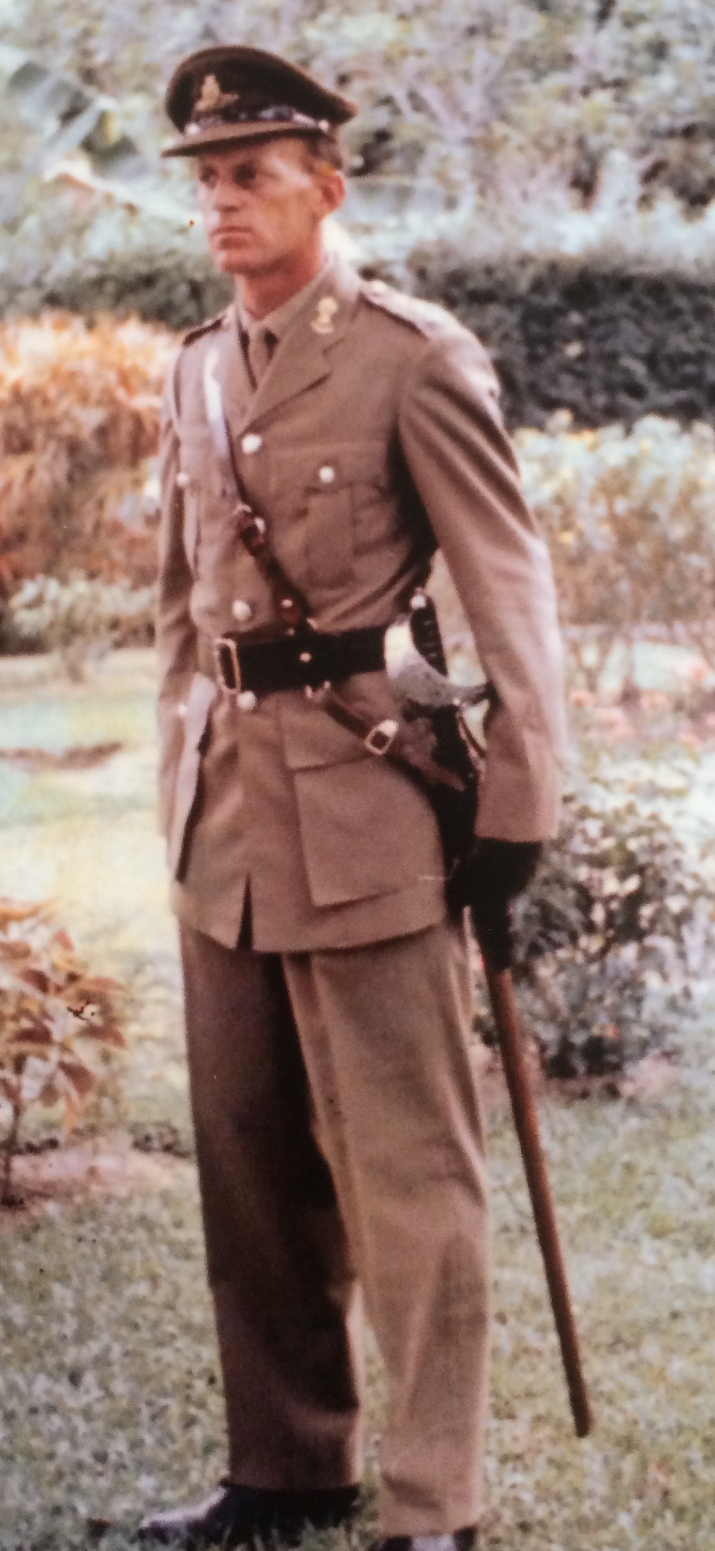
He was promoted Captain in May 1968 and in May 1969 he was sent to Vietnam and was in that war zone for 12 months.When he arrived home from Vietnam he was commanded to join a British unit based in Wales and his family went with him.
They stayed for over 2 years while the unit was developing and trialling a new surface-to-air missile system called Rapier. This British unit and David also spent 4 months in the USA trying to sell this
system to the Americans. In the event the Americans did not purchase it, but Australia did and it became the primary weapon of the 16th Artillery Regiment located at Woodside SA.
In 1973, back in Australia, David was promoted Major and was
selected to attend the prestigious 12 month course at the Australian Command and Staff College at Queenscliff VIC. 48 majors attended, 8 of whom came from overseas countries.
He said this was the highlight of his long army career.

David then occupied numerous senior staff postings in Canberra and Adelaide.
He resigned from the army in 1978 and went into hospital administration, becoming the Chief Executive Officer of Modbury Hospital. This was both challenging and rewarding, in equal parts!
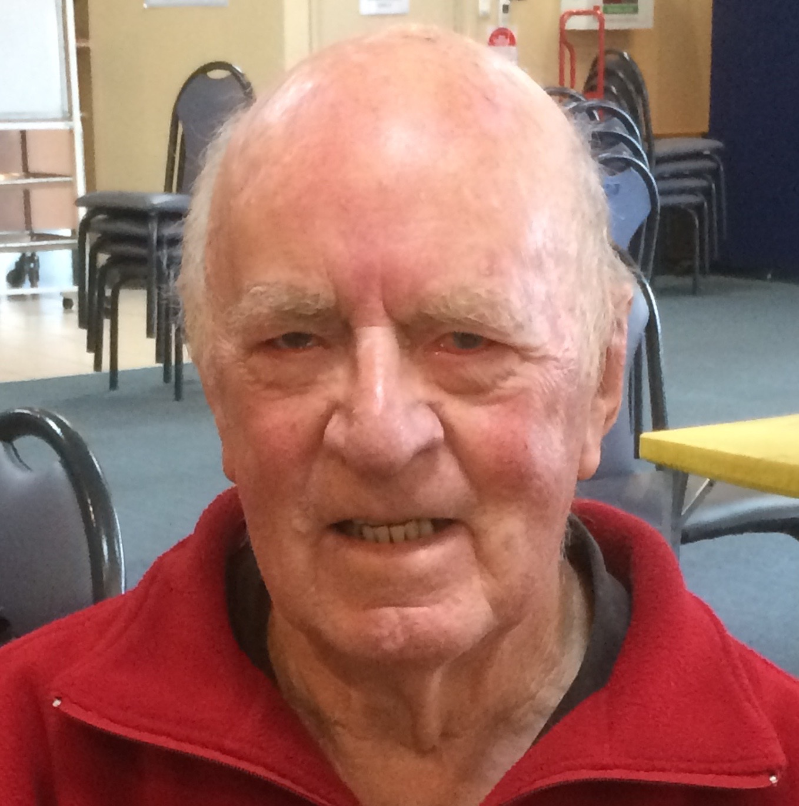
After spending 15 years with the hospital, he resigned to take up accounting duties with two travel agencies, one in Adelaide the other in Sydney. Both were owned by his daughter. This was the ultimate ‘launching pad’ for many overseas trips, at hugely discounted (travel agent) prices.
He and his wife, Yvonne, now enjoy their 1 daughter and 3 sons, their 13 grand-children and recently twin great-grandsons and a contented retirement in a village on Anzac Highway.

David has been a member of the Glenelg Bridge Club for about four years. He enjoys the challenge of the game of bridge, and plays every Friday and occasionally on Mondays. At the same time he always enjoys the company of other members of the Club.Thank you , David

June Hammond

Member’s Profile - John Jeffery

It recently came to my attention that one of our regular Tuesday night players has been playing bridge at the club since it was founded in 1970.
John Jeffery was born in Owen, a small town near Balaclava where his mother was a high schoolteacher. His family were all card players and so John first started to play bridge around the age of 10.
Though still at primary school, John was aware of an incident during the war that had quite an impact on his family. His grandfather was a boot maker and borrowed quite a sum of money to send a large consignment of boots to Sydney. The entire cargo was lost when the ship was sunk by the Japanese.
John’s father bought a shop in Seacliff and the family moved to Jetty Road, Brighton in 1945 so John could continue his studies at Prince Alfred College. During this time Jeffery family were involved in founding the Seacliff Youth Club and John’s mother ran it for some time.
By 1950 John was attending Adelaide University and studying pharmacy while working part time in the local chemist shop.
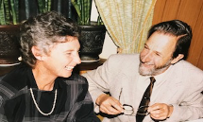
During this time John joined the CMF with the Adelaide University Regiment until he graduated in 1955 when he decided to head to Queensland to ply his new found profession.
On returning to Adelaide John played tennis at a high level and was Captain and President of the Holdfast Tennis Club. It was here that he met, courted and married Janet Galloway.
That was 1960 and they are still happily married more than 60 years later. Around this time John began playing bridge as a part of a small club in Partridge Street before it moved to the rear of the Glenelg Police Station in Moseley Square. They later relocated to the Glenelg Town Hall where the Glenelg Contract Bridge Club was founded in 1970.
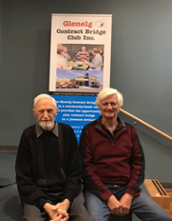
John had a very successful career as a pharmacist having successive shops in Seacliff, Glenelg and Henley Beach Rd. During this time John also bought a farm of 160 acres near Willunga which he was able to subdivide.
John and Janet are the proud parents of four sons and have 9 grandchildren.
John (pictured on left) is still playing an excellent game of bridge. He plays with Brian Lapsley (also pictured) who used to be his neighbour and continues to bring John to the club on Tuesday nights where they form a competitive partnership.

Graeme Hammond

Member Profile – Colleen Searle
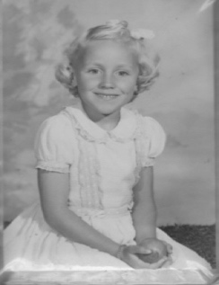
Meet one of our several dedicated and talented teachers. She is the lady with the bubbly personality and is a thoroughly conscientious and very experienced educator - Colleen Searle.
Colleen was born at Riverton on her sister’s 6th birthday, lived at Saddleworth and attended the local primary school. It was a pleasant life growing up in the rural environment.

Sickness in the family caused Colleen at the age of 7 to live on her uncle’s farm at Bute on and off for 12 months. During this period, she lived with her aging Grandma and three of her offspring all unmarried: 2 uncles and an aunt all in their thirties.
Farm life was enjoyable but different for Colleen with a 32-volt generator, party line telephone, toilet down the back amongst the pepper trees. They were very aware of water conservation. The farm was almost self-sufficient with milked cows, free range eggs from the hens, geese, their own meat usually hogget, home grown vegetables and lots of fruit trees. She attended Bute primary school for 12 months, catching the school bus which went past the farm.
Following the death of her father the family moved to Woodville. Colleen’s mother needed to find work to support the family. A new life began with Colleen attending Challa Gardens Primary School in year 4. The size of the school and living in suburbia was quite overwhelming for the young Colleen. Every holiday would see her back at Bute or sometimes Karoonda on an Auntie’s farm. Even though at a young age she was travelling on her own she enjoyed the adventure of travelling by train.
Colleen enjoyed her studies at Woodville High School, especially Maths and Science. Most girls left at the end of year 10 but Colleen felt privileged to complete her Leaving Honours. She learnt the piano for 6 years, taking an exam annually in both practical and theory. Winning a scholarship to teacher’s college enabled Colleen to attend the University of Adelaide and she graduated with a Science Degree (majoring in Mathematics) and a Diploma of Education.
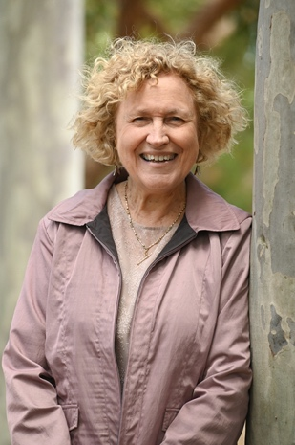
After university Colleen was married to Peter and this most probably allowed her to avoid being sent to the country. Her first teaching appointment was Kidman Park Technical High School for 3 years and then a year at Nailsworth Technical High School. She resigned at the end of 1973 to have a family. Two girls, born in 1974 and 1976. In 1983 the family moved to Murray Bridge and Colleen was lucky enough to receive a position at Murray Bridge High School and by the next year was back on the permanent staff. During her time at Murray Bridge High School, she was involved in the Outdoor Education Program where each year she went backpacking for 3 days in the Coorong and 5 days in the Flinders Ranges. In 1992, the family returned to Adelaide and Colleen spent the next 16 years at Brighton Secondary School. Most of Colleen’s career involved teaching all types of Maths classes from year 8 to Specialist Maths at year 12. She retired in 2007. Well, I am not sure that we could say RETIRED. Within 2 years 5 grandchildren joined the family and the 6th 2 years later. In the true Colleen way, she has been actively involved with the care and raising of the grandchildren, enjoying watching their many sports and extra curricula activities.
In 2008 Colleen and a group of friends found out that Glenelg Bridge club were teaching lessons to beginners. They attended classes with Peter Williams as the teacher and repeated the beginners’ course to get a clearer understanding of the basics, this time with Marie McMahon. Colleen and friends progressed to supervised bridge where they stayed for quite a few years and eventually playing competition. Colleen spent two years on the committee in 2012 and 2013 as a representative of the supervised group.
In 2020 Colleen was asked to join a group of teachers who would be looking after the supervised bridge on Tuesdays and Wednesdays. The memory of her first morning as a teacher at supervised Bridge, after a COVID lock-down, when 40 players came flowing through the door, was quite a surprise. Each supervised session includes a 10-minute Powerpoint lesson, 4 play hands on the lesson, general play and printed notes on the lesson. Three years on Colleen and her co-teacher Julie Clark have presented many a lesson to enthusiastic and appreciative participants. It is a thriving part of the club. We thank you Colleen for the professionalism, enthusiasm, dedication and friendliness that you bring to the club.
By Helen Wetherell

