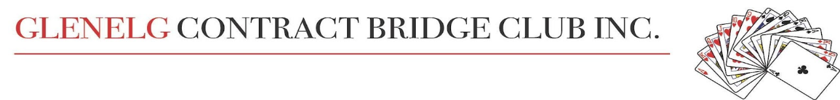Newsletter June 2023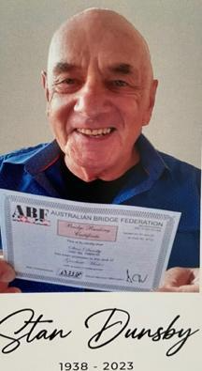

Vale Stan Dunsby
Many of us were deeply saddened to hear of Stan’s recent passing.
Despite multiple serious health concerns, he always had a positive attitude
and his cheeky humour endeared him to all of us. He will be missed.

Judy Roinich

Shout-out Time
There are so many deserving people in our fabulous Glenelg Bridge Club who deserve huge accolades, but it would be rather remiss not to acknowledge and give thanks to our fantastic mentors, who currently are the real flavour of the month.
Warwick Bowden is the power-house behind this very active group of people, a huge task of finding suitable days, organising and pairing people. What an excellent job he has done. A big thank you to Warwick, definitely the right man for the job.
Brilliant players themselves, club mentors, volunteer their time and willingly share their expertise to assist the Intermediate members of our club.
We are all extremely appreciative and grateful to have enjoyed the opportunity to have these patient, kind people, mentor and help us to grow in knowledge, skill and confidence in the game we all enjoy so much.
‘A big shout-out to all mentors.’
Recently a number of Intermediate players courageously joined the ranks of competition and it is fitting at this time to also thank the regular competition players who offer their knowledge, tips and encouragement to help us on our way.

Lyn Keeley

National Volunteer Week
The article written by Lyn is very timely as we celebrated National Volunteer Week (15 -21 May), Australia's largest annual celebration of volunteering with the 2023 theme of The Change Makers.
It is a chance for all of us to celebrate and recognise the vital work of volunteers at our bridge club. At Glenelg Bridge Club we have volunteers in many capacities from management committees, directors, teachers, board dealers, mentors, library, making tablecloths, session helpers and in many more ways - people jumping in and doing what needs to be done when required.

To all who give their time and efforts, it is very much appreciated and a big THANK YOU.

A BIG Day Out- 2023 Autumn Nationals

New Event – Rookie, Butler Swiss Pairs for players with fewer than 35 Masterpoints. One day event on Thursday 4th May at the Ridley Centre, Adelaide Showground at Wayville
Barbara Travis and her team are to be commended for the excellent preparation, organising, coordinating and facilitating of the day. It seemingly ran as smoothly and effortlessly as the projected timer on the ‘N’ wall.
A few weeks prior to the ‘Big Day’, Barbara kindly attended one of our Thursday supervised sessions to explain and encourage intermediate players to attend the event.
This resulted in a number of rookies from our club being inspired to ‘give it a go.’
Arriving at the Showground we proceeded to the HUGE Ridley Centre to find the area already abuzz.
A large number of players were in attendance. The Rookie section, consisting of 15 tables, i.e. sixty players, only a small part of the overall competitions.
Other tournaments for more experienced players were taking place at the same time.
Reference sheets on entry, provided information to table numbers and the position of play.
The various tournaments were defined by placards on the ‘S’ wall and different coloured cloths on the tables.
Opening the event Barbara explained the logistics of the day and offered a warm welcome to all. Special mention was made of the privilege and honour of having Ron Klinger, author and Australian Grand Master, and other prominent players, present in Adelaide.
Play commenced promptly at 09.30am, the competition, Butler Swiss Pairs. A new experience for us!
In total six rounds of eight boards were played. At the end of each round the results were assessed.
Winners moved towards the top of the queue and those with lesser scores, in the opposite direction.
The boards were usually completed with a little time to spare and this enabled social time with
friendly new faces.
Barbara was our director for the day and she was ably assisted in particular by Anton, aged fourteen.
Anton, polite and pleasant, provided new boards, attended to Bridgemate discrepancies, acted as a director when he was able and readily sorted fallen bidding boxes. What a gem, he didn’t stop the entire day!
Congratulations to the winners, John Pumpa/Richard Collis. Runners-up, Lewis Jones/Jake Howie.
Achieving great results, Carmel Langley/Pam Murphy and Di Harvey/Henry Konetschka did themselves and our club proud, too.
In summary a very enjoyable, if exhausting, day of comaraderie and competition.

Lyn Keeley

ANOT Rookie Butler Swiss Pairs (May 4th 2023) Results
Congratulations to our top 5 pairs: 6th Carmel Langley/Pam Murphy
7th Henry Konetschka/ Diane Harvey
8th Robbie Randall/ Bob Williams
14th Sue Roberts /Deb Hicks
15th Di Griggs/ Sharon Harris

Promotions for year to April 2023
GLENELG CONTRACT BRIDGE CLUB INC
NAME | ABF NO | HOME CLUB | RANK | DATE | TOTAL  MPs | 2023 MPs | 2023 RANK
De Bellis, David | 196118 | 5-715 | Bronze National | Mar-23 | 205.54 | 13.25 | 1,388
Clark, Julie | 929182 | 5-715 | National | Mar-23 | 258.25 | 15.35 | 1,152
Stucley, Graham | 947059 | 5-710 | National | Feb-23 | 172.54 | 12.87 | 1,435
Walshe, Keith | 598501 | 5-715 | Bronze State | Apr-23 | 278.38 | 8.25 | 2,422
Turnbull, Peter | 1051393 | 5-720 | Bronze Regional | Feb-23 | 107.04 | 11.56 | 1,638
Glennon, Rose | 234036 | 5-715 | Bronze Regional | Jan-23 | 101.51 | 1.94 | 9,088
Lapsley, Brian | 786780 | 5-710 | Bronze Regional | Apr-23 | 100.14 | 2.03 | 8,815
Miller, Charmaine | 1102214 | 5-715 | Regional | Apr-23 | 50.13 | 3.70 | 5,455
Di Lernia, Lino | 1044079 | 5-701 | Silver Local | Jan-23 | 42.38 | 7.95 | 2,523
Tyler, Jillian | 839371 | 5-715 | Silver Local | Mar-23 | 36.50 | 2.61 | 7,324
Burley, Jill | 848573 | 5-701 | Silver Local | Feb-23 | 35.07 | 0.34 | 18,761
Giles, Peter | 996750 | 5-715 | Bronze Local | Feb-23 | 26.63 | 2.39 | 7,809
Lever, Chris | 894321 | 5-715 | Bronze Local | Mar-23 | 25.20 | 2.21 | 8,265
Wielgosch, Voytek | 1125303 | 5-715 | Local | Mar-23 | 16.88 | 8.16 | 2,452
Stroud, Frank | 1097954 | 5-715 | Local | Mar-23 | 16.81 | 2.99 | 6,547

OTHER RESULTS
Well done to all who participated in these events but special congratulations to the following:
State-wide Pairs Competition 20th and 21st April 2023
Novice section 1st N-S Chris Colmer and Ann Seale
E-W Andrea Dayman & Voytek Wielgosch
Open section 7th Rod Macey and Christian Mehuys
Australia Wide Restricted Pairs May 25th 2023
A very successful event at our club with 12 tables being directed by Bill Jensen.
1st N-S Max Kloeden and Gonz Uyttenhove
E-W Janet Johnson and Rose Willington
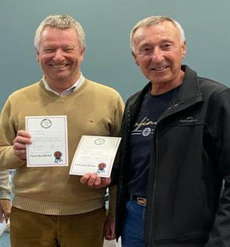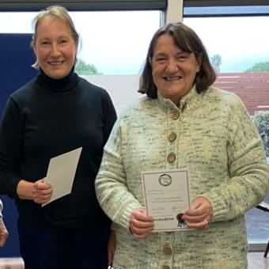

Congratulations to our Julies
After recent trials at SABA, Julie Clark and Julie Roberts have been selected to represent South
Australia (and Glenelg Bridge Club) in the Perth Australian National Championship in the Restricted Butler Pairs Event from July 15th-16th July. Well done and best of luck in July!

CLUB GNOT PLAYOFF
To be held SATURDAY JUNE 3rd, 2023 Results in next newsletter
An Interesting Hand
Recently at an Intermediate Session on Thursday, we gave a short presentation on cue bidding and in particular, Michael’s Cue Bid.
This hand came up during play, so cue bidding was front of mind.

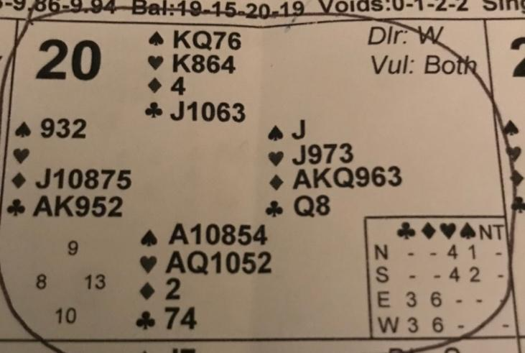

The bidding went as follows: WEST NORTH EAST SOUTH

PASS PASS 1D 2D
3D 4D 5D 5H
ALL PASS

Analysis : West could have opened the Unusual 2NT showing both minors and weak, which is in some systems, but not in theirs and passed.
North has nothing to bid at this stage and passes.
East opens 1D, 13HCP and 6 card diamonds.
South has 2x 5 card majors and 10 HCP and cue bids 2D, Michael’s cue bid.
West now bids 3D, adding extra points for the void and supporting partner’s opening bid
( could have bid 4D).
North has both majors 4-4, and cuebids 4D, to show a 10+ hand, telling partner about the 4-4 majors and asking partner to choose their best major.
East now bids 5D
South chooses hearts with 2 honour cards and bids 5H
West passes and all pass.

Contract 5H, going down 1
You can see that 6D was makeable but no-one in the session put on their “cloak of courage” and bid this.

The amazing thing was seeing the first 5 bids in diamonds on the table, all telling an interesting story.

