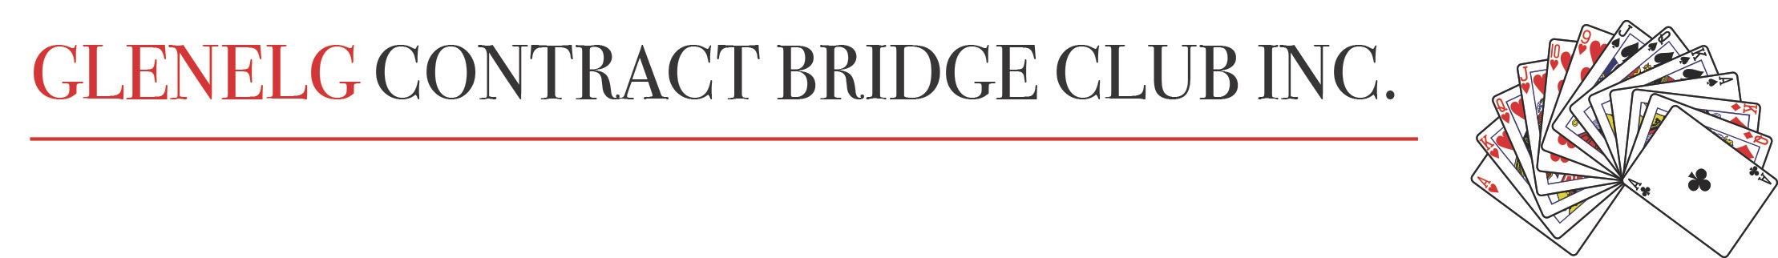Newsletter November 2023

Special General Meeting
The new Constitution of the Glenelg Contract Bridge Club was voted on at the Special General Meeting held on Tuesday, November 7th at 12 noon. The new Constitution was unanimously accepted by the 56 members present, with no-one speaking against the motion. The new Constitution will now be lodged with the Office of Business and Consumer Affairs for approval in accordance with the Act. Many thanks to the dedicated committee who worked on the new Constitution: Anne Stimson, Warwick Bowden and chaired by Bill Jensen.

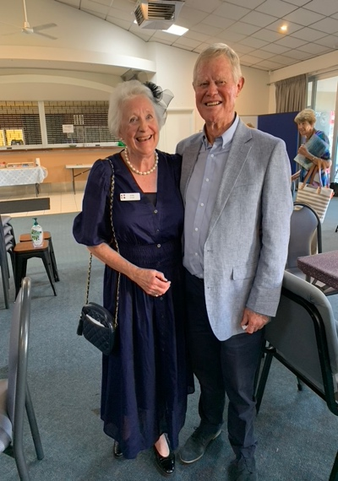
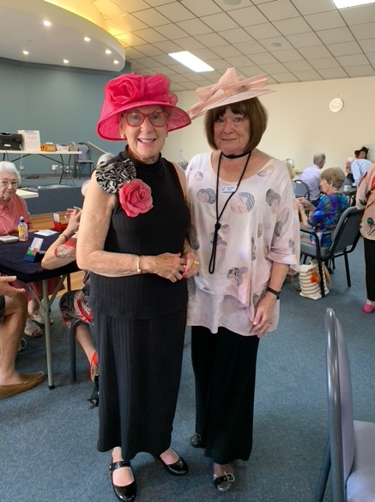
Melbourne Cup at Glenelg Bridge Club
After the SGM, there was a real buzz in the air as we enjoyed a shared lunch and a glass of bubbly before settling down to bridge until a break for afternoon tea and the Melbourne Cup. Thank you to John Hayles who organized the sweep as he has done for several years. Best dressed was awarded to Patricia McGaffin and Samantha Rowe and best dressed pair to Josie and Geoffrey Cock.
Male members of the club were encouraged to make a bit more of an effort next year.

Bridge Results: Australia-Wide Open Pairs
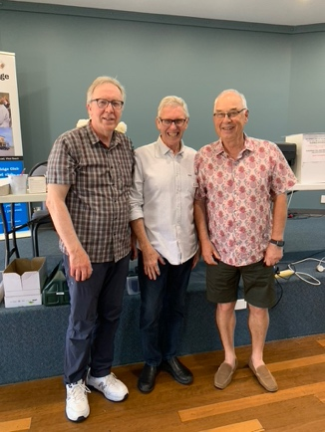
Petter Carlmark and Bill Jensen had a good day on Wednesday 30 August, in the Australia-Wide Open Pairs, and scored 67.4, finishing 12th in Australia and the regional winners for SA/NT. Their accomplishment was recognised by the ABF and they were presented with engraved pens.
Well done Bill and Petter.

Australia-Wide Restricted Pairs

This year we held two sessions of the Australia-Wide Restricted Pairs on Thursday 26 October.
This event is for players with less than 300 masterpoints.
In the afternoon session, there were 32 players; that is eight (8) tables, and we ran a Mitchell movement.
The North / South winners were Jen Clarke and Helena Saj-Rynes with a score of 57.44 and the East / West winners were Paul Acfield and Graham Stucley with a score of 69.35.
When the scores were finalised nationally Paul and Graham finished 5th overall in Australia.
In the night session there were twelve (12) players and we ran a three (3) table Howell movement (pairs ranked 1 to 12). The winners of the night event were Ray Daws and John Gilchrist with a score of 57.50.

Congratulations to the winners and to all who participated.

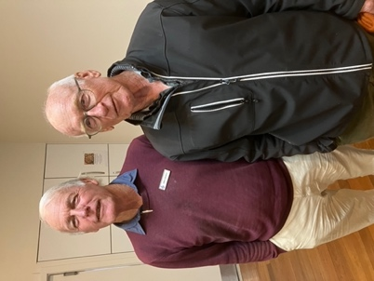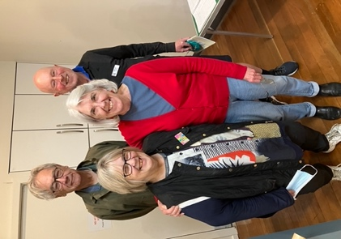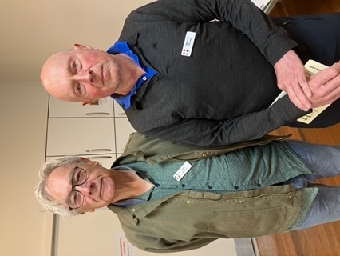

Masterpoint Rank Promotions for October
Paul Williams Graduate Master
Helena Saj-Reynes Club Master
Jen Clarke Club Master
Ros Green Club Master

As this is that last newsletter for 2023, the executive and the committee of Glenelg Contract Bridge Club wish all members a safe and happy Christmas and best wishes for the New Year.

